# TITLE OF PROJECT



# Employee Time sheet

# and

# attendance management

Members of the project

# Vamsi Krishna

# Reg no: 9920004438

# Manohar

# Reg no: 9920004428

# Mirza Adnan Baig

# Reg no: 9920004436

# Prasad

# Reg no: 9920004381

Course overview

# Used Modules:

# import java.sql.*;

# import java.awt.event.*;

# import java.io.*;

# import java.awt.*;

# import javax.swing.*;

# import java.util.Scanner;

Concepts covered ☺

# Inheritance:

# Method:

# MySQL Database:

# File handling:

# Graphical User Interface:

# .Frame

# .Button

# .Label

# Constructor:

# Switch case:

# Do-While Loop:

# If-else-if ladder:

# Try catch finally block:

RESPONSIBITIES

# P.Vamsi Krishna (9920004438)

# . CodeWriter

# D.Manohar (9920004428)

# . DataBaseConnecter

# Mirza Adnan Baig (9920004436)

# . ExcelSheet Writer

# Prasad (9920004381)

# . Idea About OverAll Project Presenter

WORKING OF OUR CODE

# . Login System

# . Advertising

# . Apply For A Job

# . Storing Employee Attendance In Mysql Database

# . Storing Employee Salary And Time Sheet In Mysql Database

# . Reiterving Employee Attendance,Salary,Time_Sheet and Who Applied

# For Job

# . Employee Details

# . Employee Attendance

# . Employee Time Sheet, Employee DataBase

Source Code

# Class (Main.java)

package vamsi;

public class Main {

public static void main(String[] args) {

gui obj = new gui();

}

}

………………………………………………………………………………………………………………………………………………………............

# Class (Main0.java)

package vamsi;

import javax.swing.*;

import javax.swing.border.EmptyBorder;

import java.awt.*;

import java.awt.event.ActionEvent;

import java.awt.event.ActionListener;

class Main0 extends JFrame {

JFrame frame;

JLabel label;

JPanel panel;

JLabel lblNewLabel;

JLabel lblNewLabel_1;

JButton btnNewButton;

ImageIcon image;

Main0()

{

image = new ImageIcon("C:\\Users\\VOOHA\\Pictures\\Saved Pictures\\Instagram\\2dgraphics_2.jpg");

frame = new JFrame();

frame.setTitle("Welcome Page");

frame.setDefaultCloseOperation(JFrame.EXIT_ON_CLOSE);

frame.setBounds(500, 500, 550, 550);

frame.setResizable(false);

frame.setVisible(true);

panel = new JPanel();

panel.setBorder(new EmptyBorder(5, 5, 5, 5));

frame.add(panel);

panel.setLayout(null);

lblNewLabel = new JLabel("WELCOME TO EMPLOYEE PORTAL");

lblNewLabel.setFont(new Font("Tw Cen MT", Font.BOLD, 28));

lblNewLabel.setBounds(30, 25, 420, 40);

panel.add(lblNewLabel);

lblNewLabel_1 = new JLabel();

lblNewLabel_1.setIcon(image);

lblNewLabel_1.setVerticalTextPosition(JLabel.CENTER);

lblNewLabel_1.setVerticalAlignment(0);

lblNewLabel_1.setBounds(25,25,480,480);

panel.add(lblNewLabel_1 );

btnNewButton = new JButton("Registration Form");

btnNewButton.setBounds(340, 450, 150, 23);

btnNewButton.setFocusable(false);

panel.add(btnNewButton);

btnNewButton.addActionListener(new ActionListener() {

public void actionPerformed(ActionEvent evt) {

Main5 NewWindow_3 = new Main5();

frame.dispose();

}

});}}

# Class (Main 1.java)

package vamsi;

import java.awt.*;

import java.awt.event.*;

import java.io.*;

import java.sql.*;

import java.util.Scanner;

import javax.swing.*;

class gui extends JFrame {

ImageIcon image;

JFrame frame;

JButton button;

JLabel label;

JLabel label_1;

JLabel lblNewLabel;

JLabel lblNewLabel_1;

JLabel lblNewLabel_2;

private JPanel panel;

private JTextField User;

private JTextField Password;

gui()

{

// Frame

frame = new JFrame();

frame.setTitle("Login Page");

frame.setSize(750,750);

frame.setDefaultCloseOperation(JFrame.EXIT_ON_CLOSE);

//frame.getContentPane().setBackground(Color.yellow);

frame.setResizable(false);

frame.setLayout(new BorderLayout());

frame.setVisible(true);

frame.setContentPane(new JLabel(new ImageIcon("C:\\Users\\VOOHA\\Pictures\\Saved Pictures\\Instagram\\Nature3.jpeg")));

frame.setLayout(new FlowLayout());

label = new JLabel();

frame.add(label);

frame.setSize(730,730);

// Panel :- Sub Frame

panel = new JPanel();

panel.setBackground(Color.WHITE);

panel.setBounds(150,150,400,400);

frame.add(panel);

// Label :- Login Page

lblNewLabel = new JLabel("LOGIN !");

lblNewLabel.setFont(new Font("Times New Roman", Font.BOLD, 30));

lblNewLabel.setBounds(100, 39, 250, 65);

panel.add(lblNewLabel);

// Label :- UserName

lblNewLabel_1 = new JLabel("UserName");

lblNewLabel_1.setFont(new Font("Tahoma", Font.BOLD, 20));

lblNewLabel_1.setBounds(100, 113, 115, 25);

panel.add(lblNewLabel_1);

// Label :- Password

lblNewLabel_2 = new JLabel("Password");

lblNewLabel_2.setFont(new Font("Tahoma", Font.BOLD, 20));

lblNewLabel_2.setBounds(100, 162, 115, 32);

panel.add(lblNewLabel_2);

// TextField :- User (Entry)

User = new JTextField();

User.setForeground(Color.white);

User.setBackground(Color.black);

User.setBounds(249, 113, 115, 26);

panel.add(User);

User.setColumns(10);

// TextField :- Password (Entry)

Password = new JTextField();

Password.setForeground(Color.white);

Password.setBackground(Color.black);

Password.setBounds(249, 167, 115, 25);

panel.add(Password);

Password.setColumns(10);

// Button :- AdButton

JButton AdButton = new JButton("Ad");

AdButton.setBounds(263, 250, 89, 23);

AdButton.setFocusable(false);

panel.add(AdButton);

AdButton.addActionListener(new ActionListener() {

public void actionPerformed(ActionEvent evt) {

Main2 NewWindow = new Main2();

}

});

// Button :- input

JButton input = new JButton("Apply For A Job");

input.setFocusable(false);

input.setBounds(100, 230, 125, 23);

panel.add(input);

input.addActionListener(new ActionListener() {

public void actionPerformed(ActionEvent ev) {

Main0 NewWindow_2 = new Main0();

frame.dispose();

}

});

// Button :- Login

JButton btnNewButton = new JButton("Login");

btnNewButton.setFocusable(false);

btnNewButton.addActionListener(new ActionListener() {

public void actionPerformed(ActionEvent e) {

try{

String url = "jdbc:mysql://localhost:3306/vamsi";

String user = "root";

String password = "8500095971@Vk";

Class.forName("com.mysql.cj.jdbc.Driver");

Connection conn =DriverManager.getConnection(url,user,password);

Statement st = conn.createStatement();

String sql = "Select * from EmployeeDetail where UserName = '"+User.getText()+"' and Password = '"+Password.getText()+"'";

ResultSet rs = st.executeQuery(sql);

if(rs.next())

{

JOptionPane.showMessageDialog(null, "Login Successfully");

frame.dispose();

run();

Scanner s = new Scanner(System.in);

System.out.println();

System.out.println("####################### ^^^^^ $$$ New Appplications Of Employees From Database $$$ ^^^^^ ###################");

System.out.println();

System.out.print("Want To See Employee Data From MySql Database If Yes Type 'Y' : ");

char owner_2;

owner_2 = s.next().charAt(0);

System.out.println();

if(owner_2== 'Y')

{

NewApplications();

}

System.out.println();

System.out.println("####################### ^^^^^ $$$ Employee Details From Database $$$ ^^^^^ ###################");

System.out.println();

System.out.print("Want To See Employee Data From MySql Database If Yes Type 'Y' : ");

char owner_3;

owner_3 = s.next().charAt(0);

System.out.println();

if(owner_3== 'Y')

{

Database();

System.out.println();

System.out.println("Employee Time Sheet");

System.out.println();

Time_Sheet_Database();

}

System.out.println("####################### ^^^^^ $$$ Employee Time Sheet $$$ ^^^^^ #######################");

System.out.println();

System.out.print("Want To See Employee Time Sheet If Yes Type 'Y' : ");

char owner_1;

owner_1 = s.next().charAt(0);

System.out.println();

if(owner_1== 'Y')

{

TimeSheet();

}

else

{

System.out.println("Bye Have A Good Day");

System.out.println();

System.out.println("Stay Home Stay Safe");

}

}

else

{

JOptionPane.showMessageDialog(null, "Incorrect Username or Password...", "Error",JOptionPane.WARNING_MESSAGE);

}

conn.close();

}

catch(Exception s)

{

s.getStackTrace();

}

}

});

btnNewButton.setBounds(263, 216, 89, 23);

panel.add(btnNewButton);

}

public static void run() throws FileNotFoundException,ArrayIndexOutOfBoundsException

{

Scanner s = new Scanner(System.in);

String file = null;

char owner_0;

System.out.println("\n"+"####################### ^^^^^ $$$ Employee Details $$$ ^^^^^ #######################"+"\n");

System.out.print("Do U Want To Know The Employee Id Press 'Y' :");

owner_0 = s.next().charAt(0);

System.out.println();

if(owner_0=='Y')

{

EmployeeDetails();

System.out.println("^^^^^^^ $$$$$ Opening Employee Interface $$$$$ ^^^^^^^");

}

else

{

System.out.println("^^^^^^^ $$$$$ Opening Employee Interface $$$$$ ^^^^^^^");

}

do

{

System.out.print("\n"+"Enter The Employee Id : ");

int choice = s.nextInt();

System.out.println();

int r1 = 0;

int r2 = 0;

switch(choice)

{

case 0:

file = "C:\\Users\\VOOHA\\Desktop\\EMPLOYEE ATTENDANCE.csv";

break;

case 1:

r1 = 0;

r2 = 1;

break;

case 2:

r1 = 0;

r2 = 2;

break;

case 3:

r1 = 0;

r2 = 3;

break;

case 4:

r1 = 0;

r2 = 4;

break;

case 5:

r1 = 0;

r2 = 5;

break;

case 6:

r1 = 0;

r2 = 6;

break;

case 7:

r1 = 0;

r2 = 7;

break;

case 8:

r1 = 0;

r2 = 8;

break;

case 9:

r1 = 0;

r2 = 9;

break;

case 10:

r1 = 0;

r2 = 10;

break;

case 11:

r1 = 0;

r2 = 11;

break;

case 12:

r1 = 0;

r2 = 12;

break;

case 13:

r1 = 0;

r2 = 13;

break;

case 14:

r1 = 0;

r2 = 14;

break;

case 15:

r1 = 0;

r2 = 15;

break;

case 16:

r1 = 0;

r2 = 16;

break;

case 17:

r1 = 0;

r2 = 17;

break;

case 18:

r1 = 0;

r2 = 18;

break;

case 19:

r1 = 0;

r2 = 19;

break;

case 20:

r1 = 0;

r2 = 20;

break;

default :

System.out.println("Enter The Number Between 0 to 20 ");

}

file = "";

FileReader Freader = new FileReader("C:\\Users\\VOOHA\\Desktop\\Attendance.csv");

BufferedReader Breader = null;

String line = "";

if(choice==0)

{

try

{

Breader = new BufferedReader(Freader);

while((line=Breader.readLine()) !=null)

{

String[] row = line.split(",");

for(String index : row)

{

System.out.printf("%-15s",index);

}

System.out.println();

}

}

catch(Exception e)

{

e.printStackTrace();

}

finally

{

try

{

Breader.close();

Freader.close();

}

catch(IOException e)

{

e.printStackTrace();

}

}

}

else

{

try

{

Breader = new BufferedReader(Freader);

while((line=Breader.readLine()) !=null)

{

String[] values = line.split(",");

System.out.println(values[r1]+"\t\t\t"+values[r2]);

}

}

catch(Exception e)

{

e.printStackTrace();

}

finally

{

try

{

Breader.close();

Freader.close();

}

catch(IOException e)

{

e.printStackTrace();

}

}

}

System.out.println();

System.out.println("\n"+"$$$$$ Another Employee Details $$$$$");

System.out.print("\n"+"Do You Want To See Another Employee Details Enter 'Y' - ");

owner_0 = s.next().charAt(0);

}

while(owner_0 == 'Y');

}

public static void Database()

{

try

{

String url = "jdbc:mysql://localhost:3306/reportoctober";

String user = "root";

String password = "8500095971@Vk";

Class.forName("com.mysql.cj.jdbc.Driver");

Connection conn = DriverManager.getConnection(url,user,password);

Statement st = conn.createStatement();

String sql = "Select * from Employee";

ResultSet rs = st.executeQuery(sql);

Scanner b = new Scanner(System.in);

System.out.println("Attendance And Salary Report");

System.out.println();

while(rs.next())

{

String line = ",";

String s_no = rs.getString("S.NO");

String vamsi = rs.getString("1");

String adnan = rs.getString("2");

String manoj = rs.getString("3");

String sasi = rs.getString("4");

String sumanth = rs.getString("5");

String karthik = rs.getString("6");

String vijay = rs.getString("7");

String kalyan = rs.getString("8");

String saketh = rs.getString("9");

String gopi = rs.getString("10");

String aditya = rs.getString("11");

String illayz = rs.getString("12");

String prasad = rs.getString("13");

String likith = rs.getString("14");

String bharath = rs.getString("15");

String eswar = rs.getString("16");

String prudhivsh = rs.getString("17");

String varun = rs.getString("18");

String balachandra = rs.getString("19");

String nikhil = rs.getString("20");

System.out.println(s_no+"\t"+vamsi+"\t"+adnan+"\t"

+manoj+"\t"+sasi+"\t"+sumanth+"\t"+karthik+"\t"

+vijay+"\t"+kalyan+"\t"+saketh+"\t"+gopi+"\t"

+aditya+"\t"+illayz+"\t"+prasad+"\t"+likith+"\t"

+bharath+"\t"+eswar+"\t"+prudhivsh+"\t"+varun+"\t"

+balachandra+"\t"+nikhil+"\t");

}

System.out.println();

System.out.println("Database Connection Success");

System.out.println();

}

catch(Exception e)

{

e.printStackTrace();

}

}

public static void Time_Sheet_Database()

{

try

{

String url = "jdbc:mysql://localhost:3306/reportoctober";

String user = "root";

String password = "8500095971@Vk";

Class.forName("com.mysql.cj.jdbc.Driver");

Connection conn = DriverManager.getConnection(url,user,password);

Statement st = conn.createStatement();

String sql = "Select * from time_sheet_database";

ResultSet rs = st.executeQuery(sql);

Scanner b = new Scanner(System.in);

System.out.println("Attendance And Salary Report");

System.out.println();

System.out.println("SNO"+"\t"+"NAME"+"\t\t\t"+"W_HRS"+"\t"+"%"+"\t"+"PRESENT"+"\t"+"ABSENT");

while(rs.next())

{

String line = ",";

String Empid = rs.getString("EMP_ID");

String Name = rs.getString("NAME");

String Worked_hrs = rs.getString("Worked_HRS");

String percentage = rs.getString("Percentage");

String present = rs.getString("Present");

String absent = rs.getString("Absent");

System.out.println(Empid+"\t"+Name+"\t\t\t"+Worked_hrs+"\t"+percentage+"\t"+present+"\t"+absent);

System.out.println();

}

}

catch(Exception e)

{

e.printStackTrace();

}

}

public static void TimeSheet() throws FileNotFoundException

{

String Time_Sheet_File = "C:\\Users\\VOOHA\\Desktop\\time sheet (1).csv";

FileReader Freader = new FileReader(Time_Sheet_File);

BufferedReader Breader = null;

String line = "";

try

{

Breader = new BufferedReader(Freader);

while((line=Breader.readLine()) !=null)

{

String[] row = line.split(",");

for(String index : row)

{

System.out.printf("%-15s",index);

}

System.out.println();

}

}

catch(Exception e)

{

e.printStackTrace();

}

finally

{

try

{

Breader.close();

Freader.close();

}

catch(IOException e)

{

e.printStackTrace();

}

}

System.out.println("\n"+"Stay Home Stay Safe"+"\n");

}

public static void NewApplications()

{

try

{

String url = "jdbc:mysql://localhost:3306/vamsi";

String user = "root";

String password = "8500095971@Vk";

Class.forName("com.mysql.cj.jdbc.Driver");

Connection conn = DriverManager.getConnection(url,user,password);

Statement st = conn.createStatement();

String sql = "Select * from register";

ResultSet rs = st.executeQuery(sql);

while(rs.next())

{

Integer i = 1;

String fname = rs.getString("firstName");

String lname = rs.getString("lastName");

String emailid = rs.getString("emailId");

String qualification = rs.getString("qualification");

String cgpa = rs.getString("cgpa");

String M_Number = rs.getString("mobileNumber");

System.out.println("Candidate ^^^"+fname+"^^^");

System.out.println("First Name :"+fname+"\t");

System.out.println("Last Name :"+lname+"\t");

System.out.println("EmailId :"+emailid+"\t");

System.out.println("Qualification :"+qualification+"\t");

System.out.println("CGPA :"+cgpa+"\t");

System.out.println("MobileNumber :"+M_Number+"\t");

System.out.println("------------------------------------");

}

System.out.println("\n"+"Database Connection Success");

System.out.println();

System.out.println();

}

catch(Exception e)

{

e.printStackTrace();

}

}

public static void EmployeeDetails()

{

System.out.println( "ENTER - 0 - EMPLOYEE DETAILS "+" ^|^ \n"+

"ENTER - 1 - VAMSI "+" ^|^ \n"+

"ENTER - 2 - ADNAN "+" ^|^ \n"+

"ENTER - 3 - MANOJ "+" ^|^ \n"+

"ENTER - 4 - SASI "+" ^|^ \n"+

"ENTER - 5 - SUMANTH "+" ^|^ \n"+

"ENTER - 6 - KARTHIK "+" ^|^ \n"+

"ENTER - 7 - VIJAY "+" ^|^ \n"+

"ENTER - 8 - KALYAN "+" ^|^ \n"+

"ENTER - 9 - SAKETH "+" ^|^ \n"+

"ENTER - 10 - GOPI "+" ^|^ \n"+

"ENTER - 11 - ILLAYZ "+" ^|^ \n"+

"ENTER - 12 - MANOJ "+" ^|^ \n"+

"ENTER - 13 - PRASAD "+" ^|^ \n"+

"ENTER - 14 - LIKITH "+" ^|^ \n"+

"ENTER - 15 - BHARATH "+" ^|^ \n"+

"ENTER - 16 - ESWAR "+" ^|^ \n"+

"ENTER - 17 - PRUDHIVISH "+" ^|^ \n"+

"ENTER - 18 - VARUN "+" ^|^ \n"+

"ENTER - 19 - BALACHANDRA "+" ^|^ \n"+

"ENTER - 20 - NIKHIL "+" ^|^ \n");

}

}

Class (Main2.java)

package vamsi;

import javax.swing.ImageIcon;

import javax.swing.JFrame;

import javax.swing.JPanel;

import javax.swing.border.EmptyBorder;

import javax.swing.JLabel;

import java.awt.*;

public class Main2 extends JFrame {

JFrame frame;

JPanel panel;

JLabel label;

ImageIcon image = new ImageIcon("C://Users//VOOHA//Documents//Ds-programs//NewLoginSystem//ghost.png");

Main2()

{

frame = new JFrame();

frame.setTitle("AD COVID - 19 SAFETY");

frame.setDefaultCloseOperation(JFrame.DISPOSE_ON_CLOSE);

frame.setBounds(100, 100, 450, 300);

frame.setResizable(false);

frame.setVisible(true);

panel = new JPanel();

panel.setBorder(new EmptyBorder(5, 5, 5, 5));

panel.setBackground(Color.YELLOW);

frame.add(panel);

panel.setLayout(null);

JLabel lblNewLabel = new JLabel("Three Golden Rules");

lblNewLabel.setFont(new Font("Stencil", Font.PLAIN, 25));

lblNewLabel.setBounds(80, 24, 350, 37);

panel.add(lblNewLabel);

JLabel lblNewLabel_1 = new JLabel("1. \"Always Wear Mask\"");

lblNewLabel_1.setFont(new Font("Tahoma", Font.BOLD, 15));

lblNewLabel_1.setBounds(80, 82, 207, 27);

panel.add(lblNewLabel_1);

JLabel lblNewLabel_2 = new JLabel("2. \"Wash Hands With Soap\"");

lblNewLabel_2.setFont(new Font("Tahoma", Font.BOLD, 15));

lblNewLabel_2.setBounds(80, 120, 262, 26);

panel.add(lblNewLabel_2);

JLabel lblNewLabel_3 = new JLabel("3. \"Maintain Social Distance\"");

lblNewLabel_3.setFont(new Font("Tahoma", Font.BOLD, 15));

lblNewLabel_3.setBounds(80, 157, 234, 28);

panel.add(lblNewLabel_3);

JLabel lblNewLabel_4 = new JLabel("* Be Socially Responsible *");

lblNewLabel_4.setFont(new Font("Tahoma", Font.BOLD, 15));

lblNewLabel_4.setBounds(80, 196, 234, 30);

panel.add(lblNewLabel_4);

JLabel lblNewLabel_5 = new JLabel();

lblNewLabel_5.setIcon(image);

lblNewLabel_5.setVerticalTextPosition(JLabel.TOP);

lblNewLabel_5.setVerticalAlignment(0);

lblNewLabel_5.setBounds(348, 100, 76, 80);

panel.add(lblNewLabel_5);

}

}

# Class (Main3.java)

package vamsi;

import java.util.List;

import java.util.stream.Collectors;

import java.util.stream.IntStream;

import static java.util.Arrays.asList;

public class Main3

{

private static final List<Integer> x = asList(1, 2, 3, 4, 5, 6, 7);

private static final List<Integer> y = asList(3, 1, 2, 2, 8, 1, 1);

private static Double predictForValue(int predictForDependentVariable)

{

if (x.size() != y.size())

throw new IllegalStateException("Must have equal X and Y data points");

Integer numberOfDataValues = x.size();

List<Double> xSquared = x

.stream()

.map(position -> Math.pow(position, 2))

.collect(Collectors.toList());

List<Integer> xMultipliedByY = IntStream.range(0, numberOfDataValues)

.map(i -> x.get(i) * y.get(i))

.boxed()

.collect(Collectors.toList());

Integer xSummed = x

.stream()

.reduce((prev, next) -> prev + next)

.get();

Integer ySummed = y

.stream()

.reduce((prev, next) -> prev + next)

.get();

Double sumOfXSquared = xSquared

.stream()

.reduce((prev, next) -> prev + next)

.get();

Integer sumOfXMultipliedByY = xMultipliedByY

.stream()

.reduce((prev, next) -> prev + next)

.get();

int slopeNominator = numberOfDataValues * sumOfXMultipliedByY - ySummed * xSummed;

Double slopeDenominator = numberOfDataValues * sumOfXSquared - Math.pow(xSummed, 2);

Double slope = slopeNominator / slopeDenominator;

double interceptNominator = ySummed - slope * xSummed;

double interceptDenominator = numberOfDataValues;

Double intercept = interceptNominator / interceptDenominator;

return (slope * predictForDependentVariable) + intercept;

}

public static void main(String[] args) {

System.out.println(predictForValue(13));

}

}

# Class (Main4.java)

package vamsi;

import java.awt.Color;

import java.awt.FlowLayout;

import java.awt.Font;

import javax.swing.*;

public class Main4 {

JFrame Frame_1 = new JFrame();

JLabel label = new JLabel();

JLabel label_1 = new JLabel();

JLabel label_2 = new JLabel();

JLabel label_3 = new JLabel();

JLabel label_4 = new JLabel();

JLabel label_5 = new JLabel();

//Image Icon

ImageIcon image = new ImageIcon("C://Users//VOOHA//Documents//Ds-programs//NewLoginSystem//ghost.png");

Main4()

{

// Label

label_1.setIcon(image);

label_1.setVerticalTextPosition(JLabel.TOP);

label_1.setVerticalAlignment(0);

label_1.setText("Three Golden Rules");

label_2.setText("1. Always Wear Mask");

label_3.setText("2. Wash Hands With Soap");

label_4.setText("3. Maintain Social Distance");

label_5.setText("* Be Socially Responsible *");

label_1.setBounds(57, 66, 190, 35);

label_2.setBounds(60, 111, 190, 35);

label_3.setBounds(60, 148, 190, 35);

label_4.setBounds(60, 186, 190, 35);

label_5.setBounds(60, 240, 190, 35);

label_1.setForeground(new Color(0xFFFFFF));

label_1.setFont(new Font(null,Font.ITALIC,40));

label_2.setForeground(new Color(0xFFFFFF));

label_2.setFont(new Font(null,Font.ITALIC,25));

label_3.setForeground(new Color(0xFFFFFF));

label_3.setFont(new Font(null,Font.ITALIC,25));

label_4.setForeground(new Color(0xFFFFFF));

label_4.setFont(new Font(null,Font.ITALIC,25));

label_5.setForeground(new Color(0xFFFFFF));

label_5.setFont(new Font(null,Font.ITALIC,25));

Frame_1 = new JFrame();

Frame_1.setTitle("AD COVID - 19 SAFETY");

Frame_1.setDefaultCloseOperation(JFrame.EXIT_ON_CLOSE);

Frame_1.setResizable(false);

Frame_1.setLayout(null);

Frame_1.setSize(500,500);

Frame_1.setVisible(true);

Frame_1.setContentPane(new JLabel(new ImageIcon("C:\\Users\\VOOHA\\Pictures\\Saved Pictures\\Instagram\\Nature.jpeg")));

Frame_1.setLayout(new FlowLayout());

label = new JLabel();

Frame_1.add(label);

Frame_1.setSize(500,500);

Frame_1.add(label_1);

Frame_1.add(label_2);

Frame_1.add(label_3);

Frame_1.add(label_4);

Frame_1.add(label_5);

}

}

# Class (Main5.java)

package vamsi;

import java.awt.BorderLayout;

import java.awt.FlowLayout;

import java.awt.Font;

import java.awt.Color;

import java.awt.event.ActionEvent;

import java.awt.event.ActionListener;

import java.sql.Connection;

import java.sql.DriverManager;

import java.sql.Statement;

import javax.swing.*;

import javax.swing.border.EmptyBorder;

public class Main5 extends JFrame{

JFrame frame;

JLabel label;

JPanel panel;

private JTextField textField;

private JTextField textField_1;

private JTextField textField_2;

private JTextField textField_3;

private JTextField textField_4;

private JTextField textField_5;

//ImageIcon image = new ImageIcon("C://Users//VOOHA//Documents//Ds-programs//NewLoginSystem//ghost.png");

Main5()

{

frame = new JFrame();

frame.setTitle("Registration Page");

frame.setDefaultCloseOperation(JFrame.EXIT_ON_CLOSE);

frame.setBounds(100, 100, 450, 300);

frame.setResizable(false);

frame.setVisible(true);

panel = new JPanel();

panel.setBorder(new EmptyBorder(5, 5, 5, 5));

frame.add(panel);

panel.setLayout(null);

JLabel lblNewLabel = new JLabel("FirstName");

lblNewLabel.setFont(new Font("Stencil", Font.PLAIN, 15));

lblNewLabel.setBounds(27, 70, 101, 25);

panel.add(lblNewLabel);

JLabel lblNewLabel_1 = new JLabel("LastName");

lblNewLabel_1.setFont(new Font("Stencil", Font.PLAIN, 15));

lblNewLabel_1.setBounds(27, 118, 78, 25);

panel.add(lblNewLabel_1);

JLabel lblNewLabel_2 = new JLabel("Email");

lblNewLabel_2.setFont(new Font("Stencil", Font.PLAIN, 15));

lblNewLabel_2.setBounds(27, 169, 56, 25);

panel.add(lblNewLabel_2);

JLabel lblNewLabel_3 = new JLabel("New Application Form");

lblNewLabel_3.setFont(new Font("Tw Cen MT", Font.BOLD, 25));

lblNewLabel_3.setBounds(115, 11, 270, 25);

panel.add(lblNewLabel_3);

JLabel lblNewLabel_4 = new JLabel("Qualification");

lblNewLabel_4.setFont(new Font("Stencil", Font.PLAIN, 15));

lblNewLabel_4.setBounds(226, 72, 99, 16);

panel.add(lblNewLabel_4);

JLabel lblNewLabel_5 = new JLabel("CGPA");

lblNewLabel_5.setFont(new Font("Stencil", Font.PLAIN, 15));

lblNewLabel_5.setBounds(225, 122, 79, 14);

panel.add(lblNewLabel_5);

JLabel lblNewLabel_6 = new JLabel("MoblieNo");

lblNewLabel_6.setFont(new Font("Stencil", Font.PLAIN, 15));

lblNewLabel_6.setBounds(226, 173, 78, 14);

panel.add(lblNewLabel_6);

textField = new JTextField();

textField.setBounds(130, 71, 86, 20);

panel.add(textField);

textField.setColumns(10);

textField_1 = new JTextField();

textField_1.setBounds(129, 119, 86, 20);

panel.add(textField_1);

textField_1.setColumns(10);

textField_2 = new JTextField();

textField_2.setBounds(130, 170, 86, 20);

panel.add(textField_2);

textField_2.setColumns(10);

textField_3 = new JTextField();

textField_3.setBounds(314, 69, 86, 20);

panel.add(textField_3);

textField_3.setColumns(10);

textField_4 = new JTextField();

textField_4.setBounds(314, 119, 86, 20);

panel.add(textField_4);

textField_4.setColumns(10);

textField_5 = new JTextField();

textField_5.setBounds(314, 170, 86, 20);

panel.add(textField_5);

textField_5.setColumns(10);

JButton button = new JButton("AD");

button.setFocusable(false);

button.addActionListener(new ActionListener() {

public void actionPerformed(ActionEvent e) {

Main4 obj_5 = new Main4();

}

});

button.setBounds(125, 216, 89, 23);

panel.add(button);

JButton btnNewButton = new JButton("Register");

btnNewButton.setFocusable(false);

//btnNewButton.setEnabled(false);

btnNewButton.addActionListener(new ActionListener() {

public void actionPerformed(ActionEvent e) {

String firstName = textField.getText();

String lastName = textField_1.getText();

String emailId = textField_2.getText();

String qualification = textField_3.getText();

String cgpa = textField_4.getText();

String mobileNumber = textField_5.getText();

int length = mobileNumber.length();

String msg = "" + firstName;

msg += "\n";

try

{

if(firstName.isEmpty()!=true && lastName.isEmpty()!=true && emailId.isEmpty()!=true && qualification.isEmpty()!=true && cgpa.isEmpty()!=true && mobileNumber.isEmpty()!=true)

{

if(length!=10)

{

JOptionPane.showMessageDialog(btnNewButton,"Please Enter 10 Digit Number");

}

if(length>=10)

{

String url = "jdbc:mysql://localhost:3306/vamsi";

String user = "root";

String password_1 = "8500095971@Vk";

Class.forName("com.mysql.cj.jdbc.Driver");

Connection conn = DriverManager.getConnection(url,user,password_1);

Statement st = conn.createStatement();

String query = "INSERT INTO register values('" + firstName + "','" + lastName + "','" + emailId + "','" +

qualification + "','" + cgpa + "','" + mobileNumber + "')";

int x = st.executeUpdate(query);

if (x == 0)

{

JOptionPane.showMessageDialog(btnNewButton, "This is alredy exist");

//frame.dispose();

}

else

{

JOptionPane.showMessageDialog(btnNewButton,

"Welcome, " + msg + "Your Response is sucessfully Submitted");

}

JOptionPane.showMessageDialog(btnNewButton,"Thanks For Filling This Form We Will Get Back To You");

frame.dispose();

conn.close();

}

}

}

catch (Exception exception)

{

exception.printStackTrace();

}

}

});

btnNewButton.setBounds(311, 216, 89, 23);

panel.add(btnNewButton);

}

}

OUTPUT

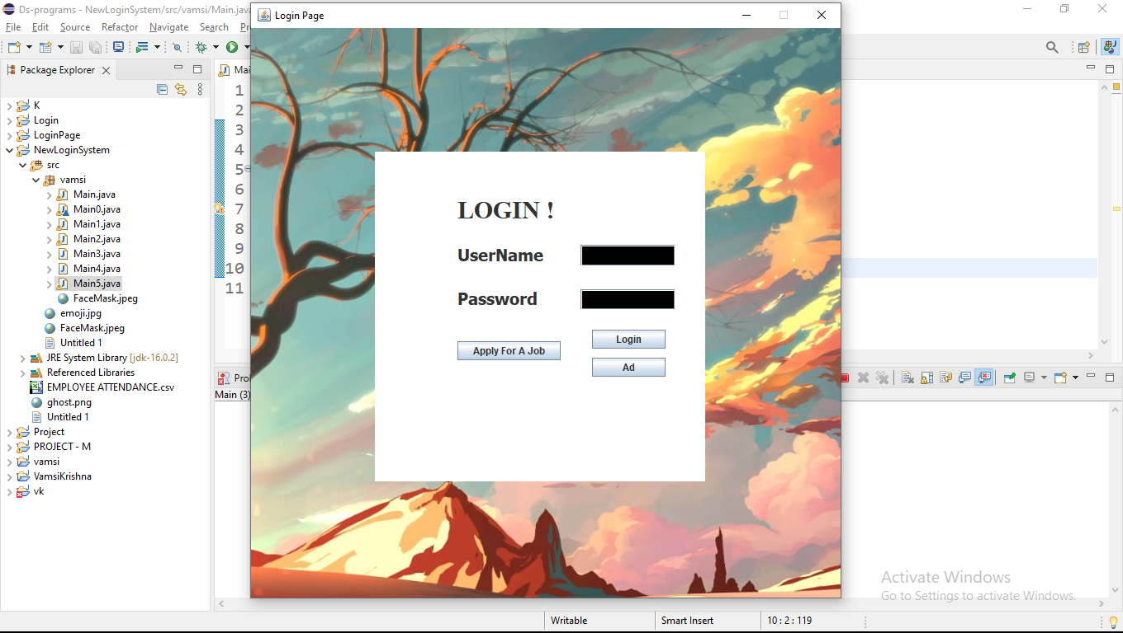

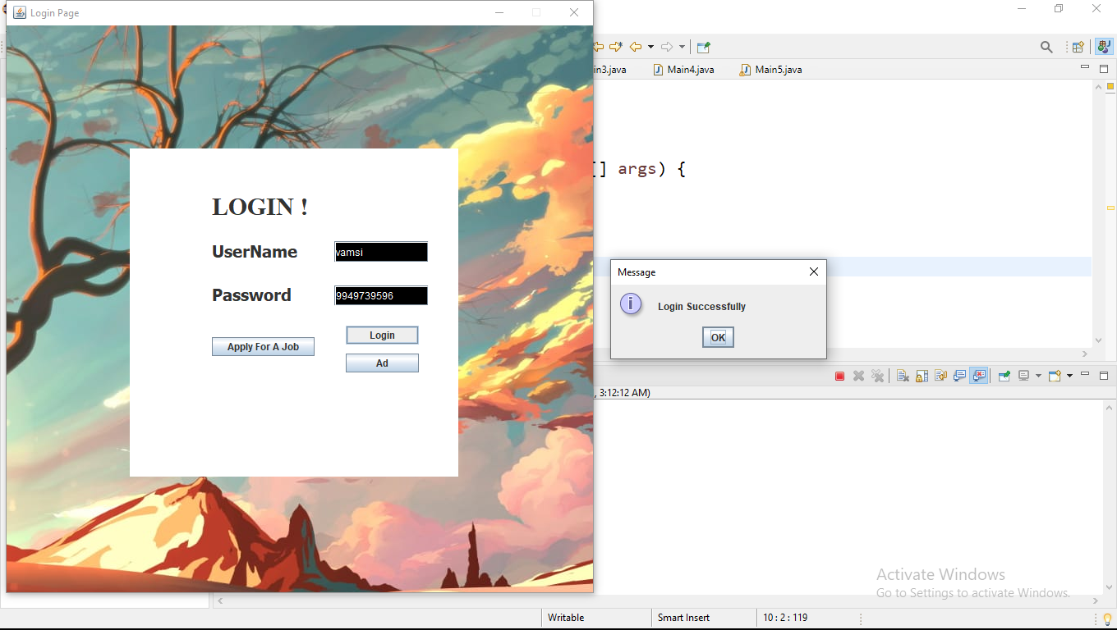

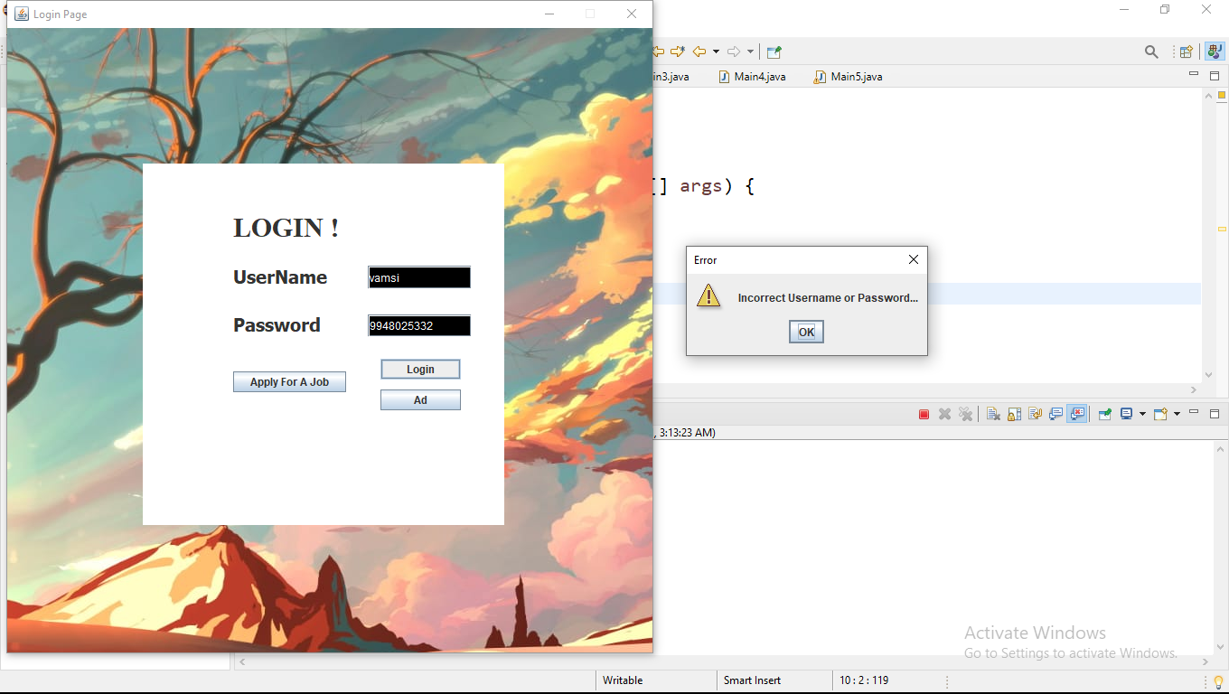

ADVERTISING

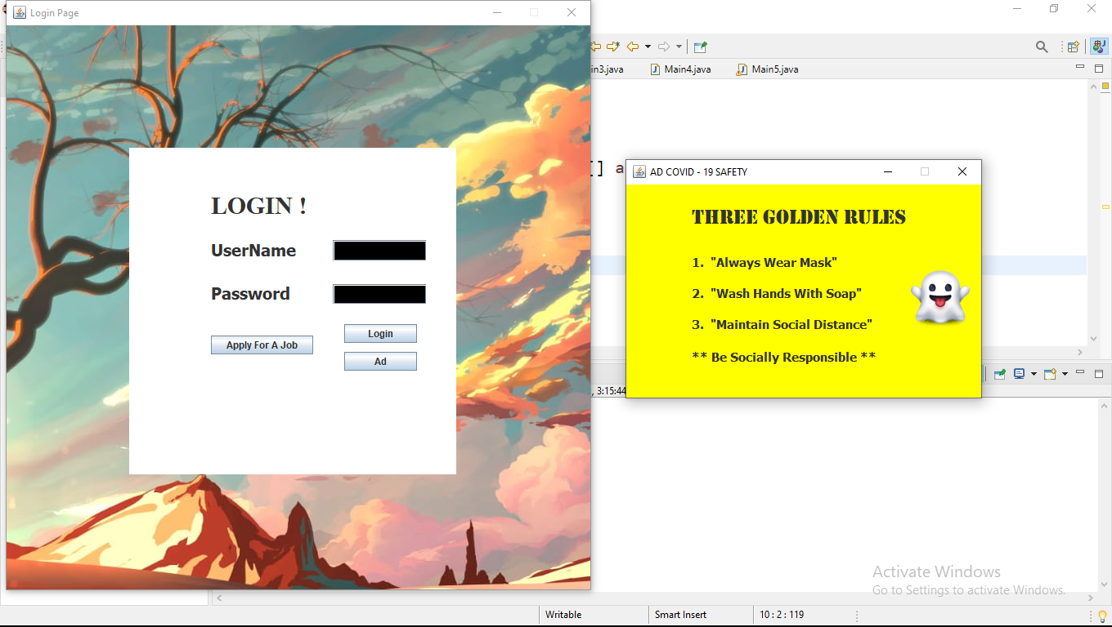

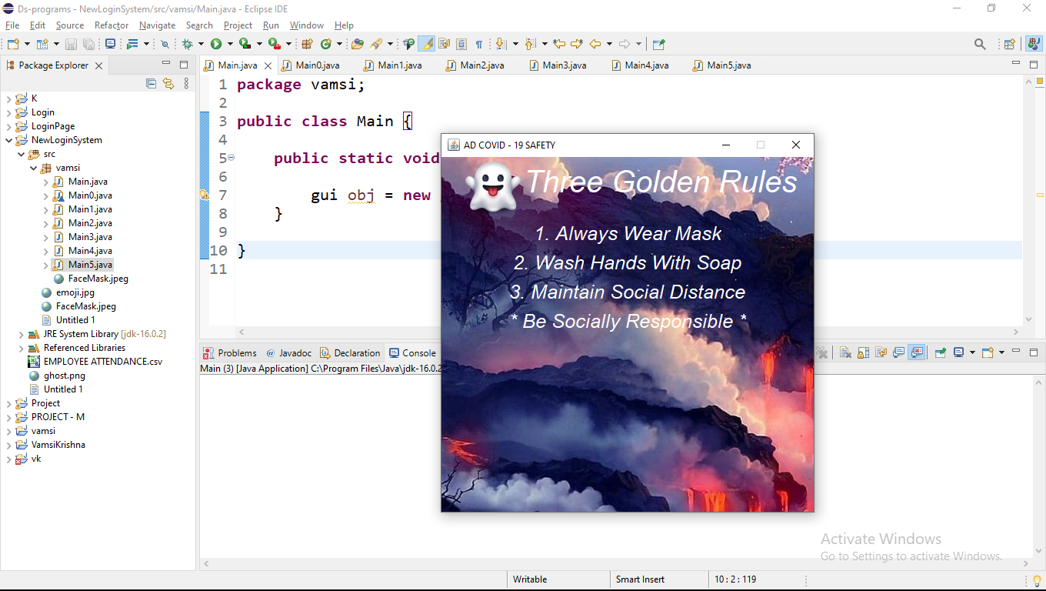

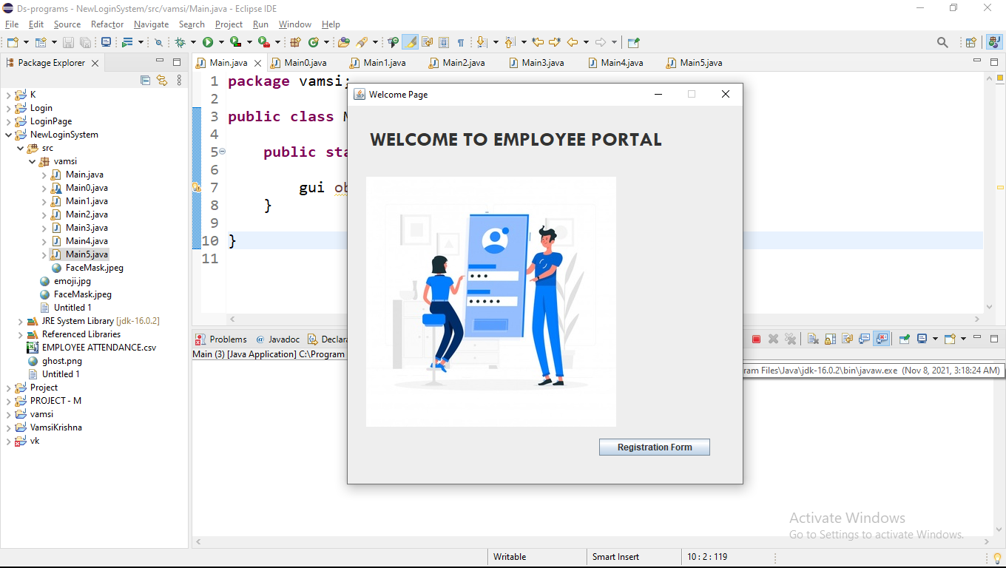

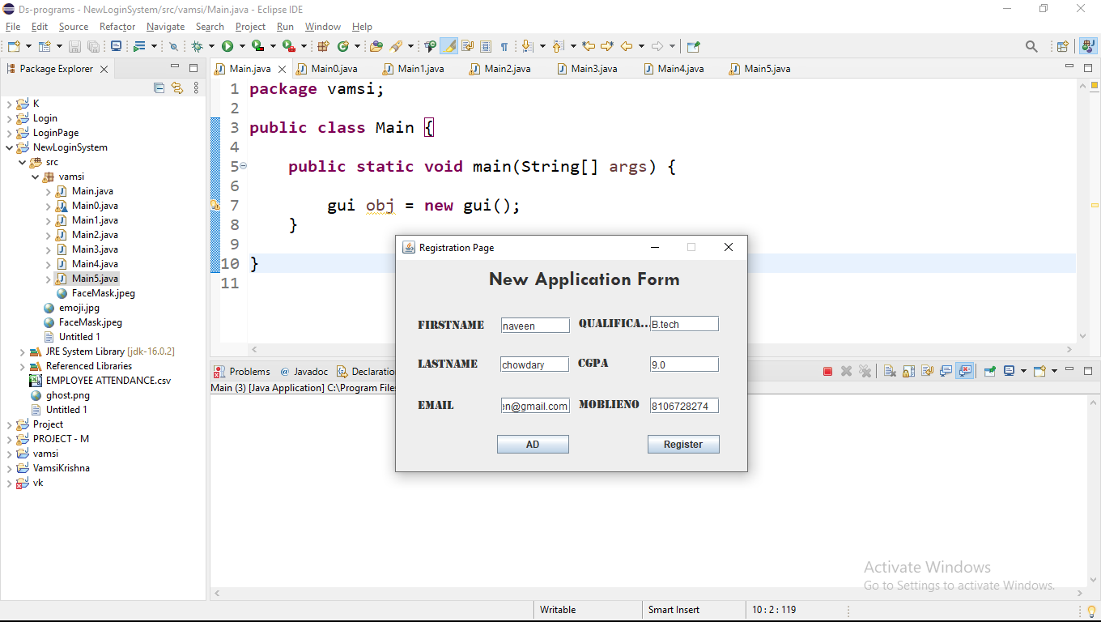

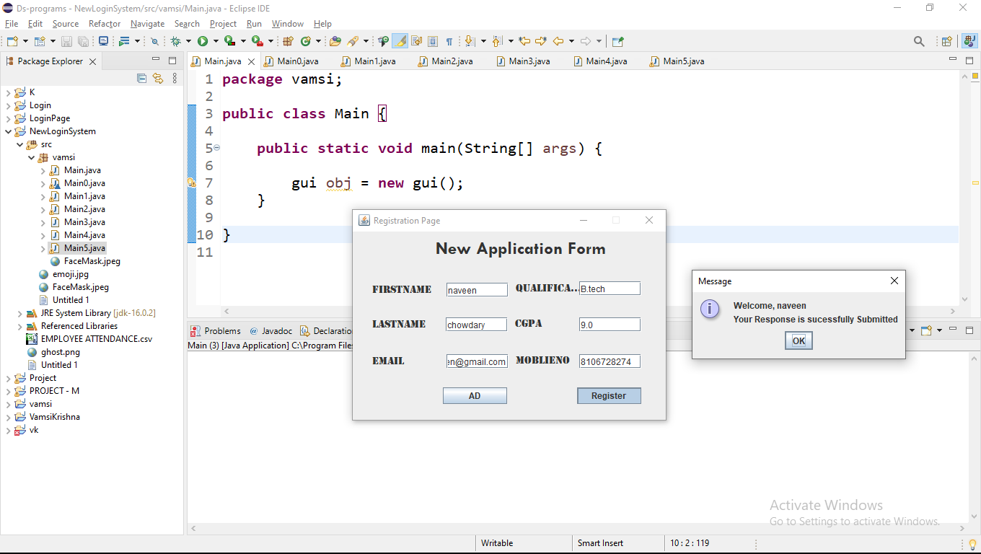

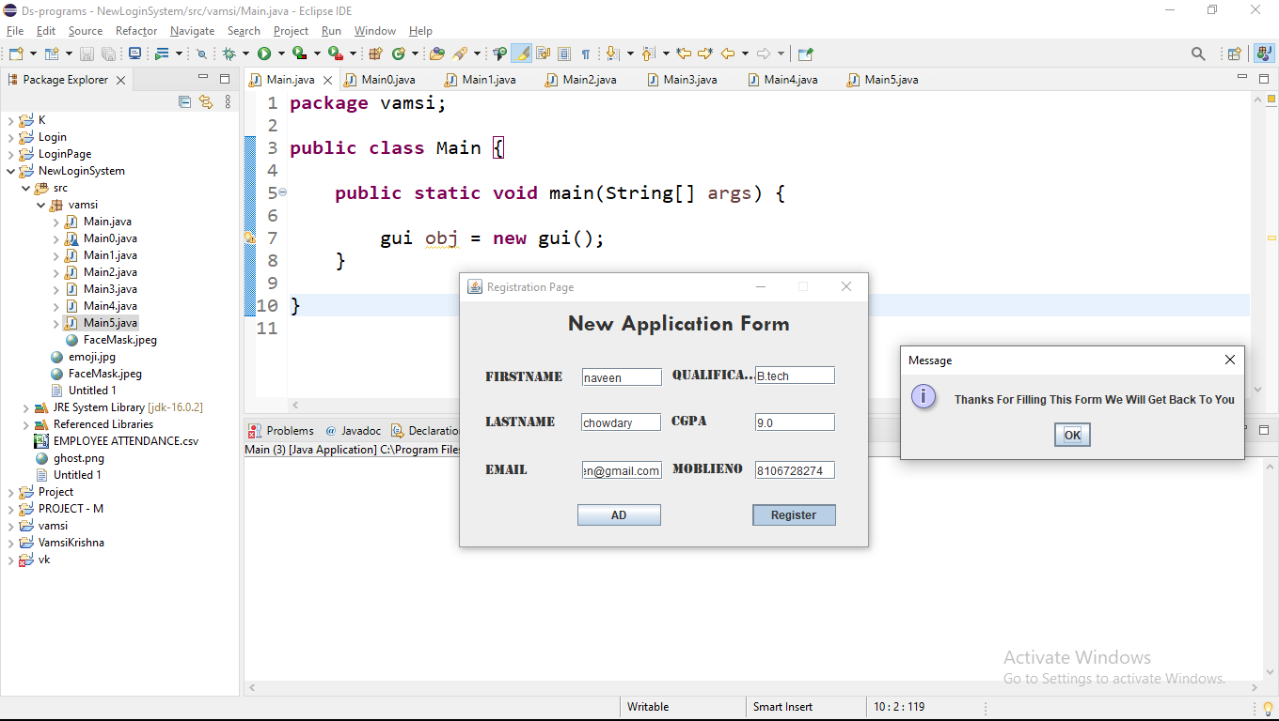

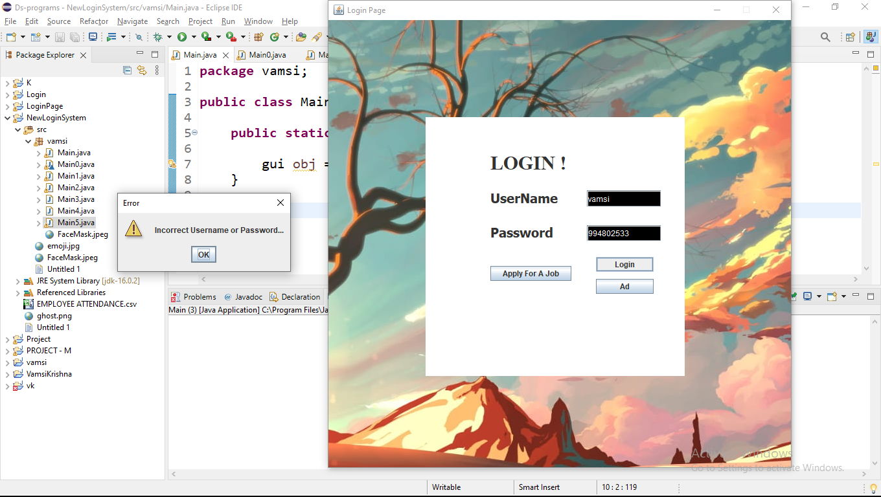

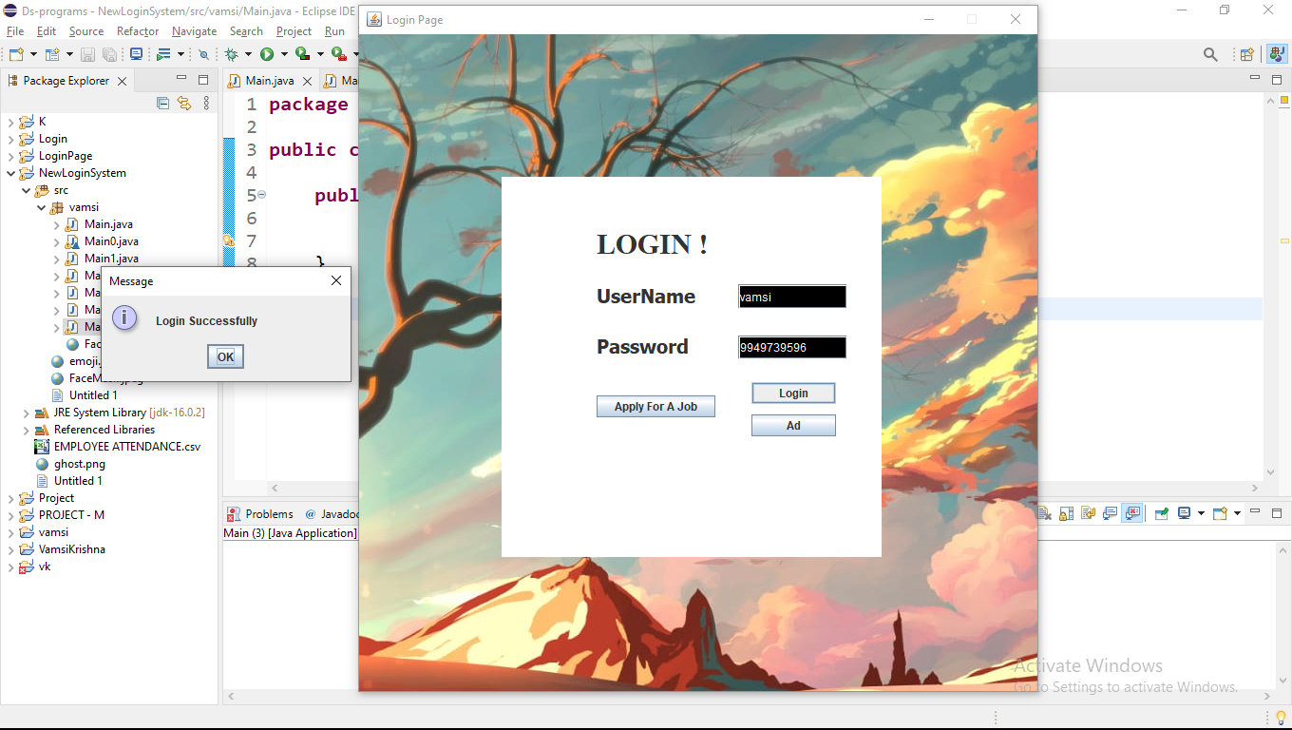

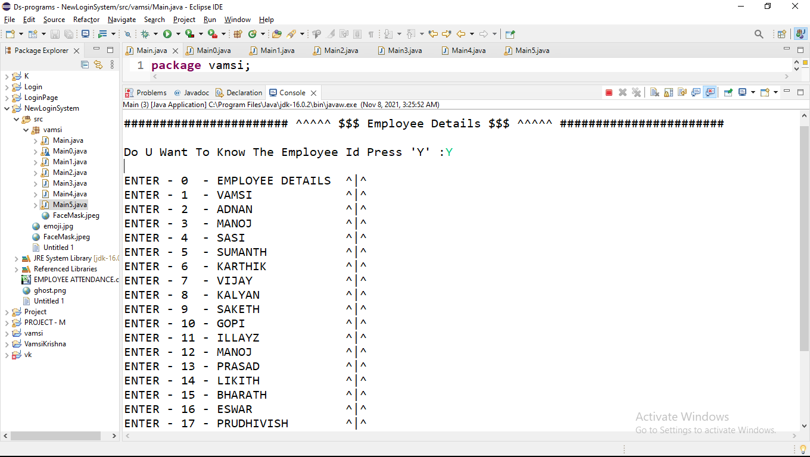

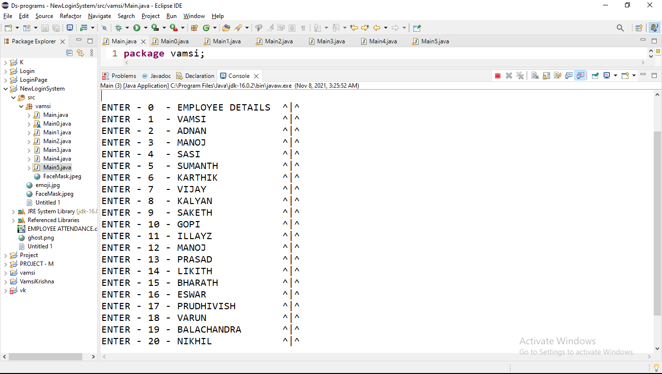

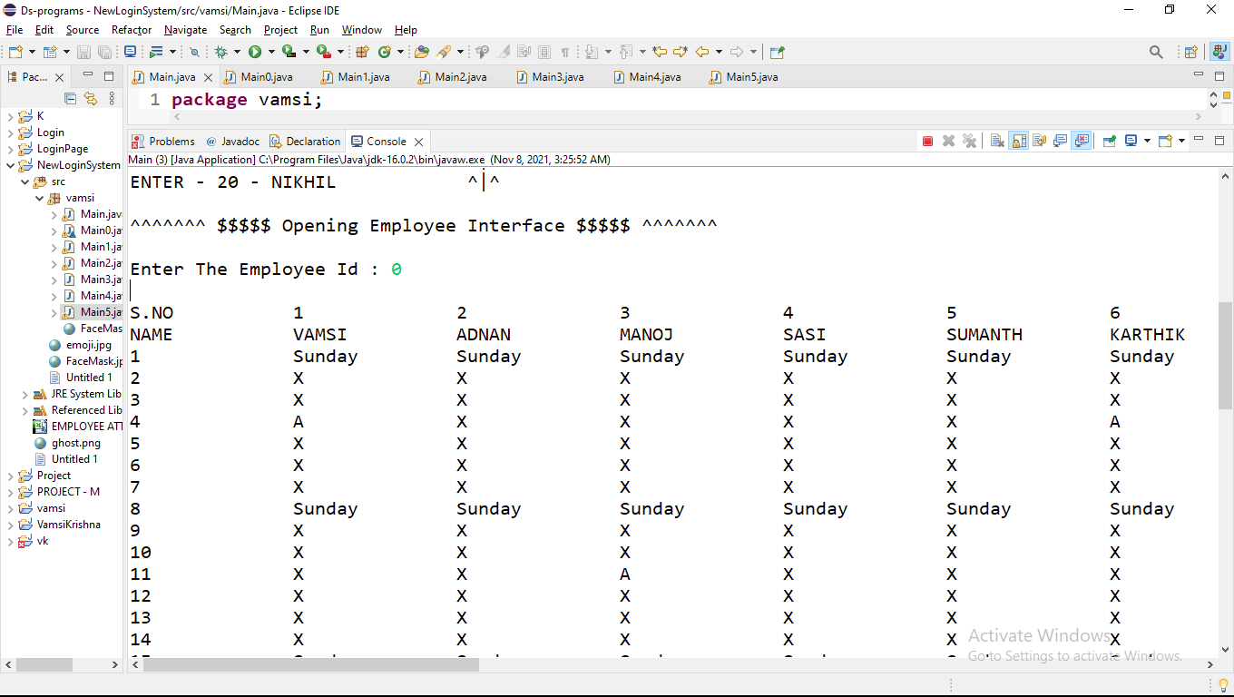

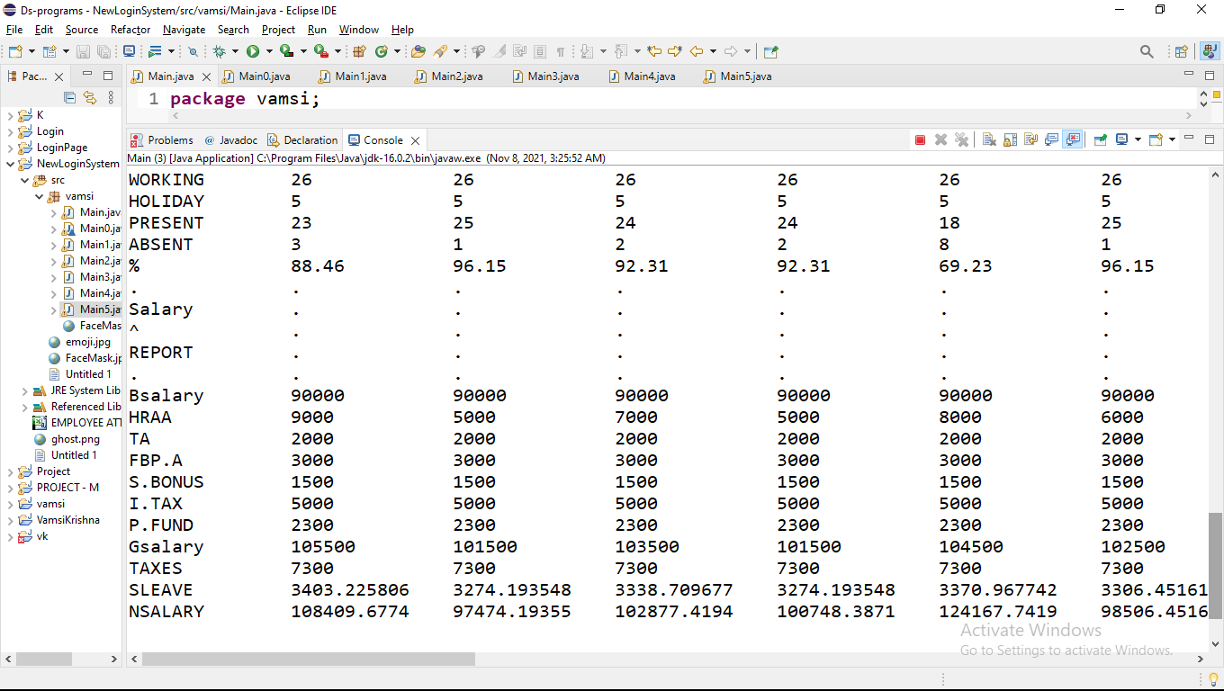

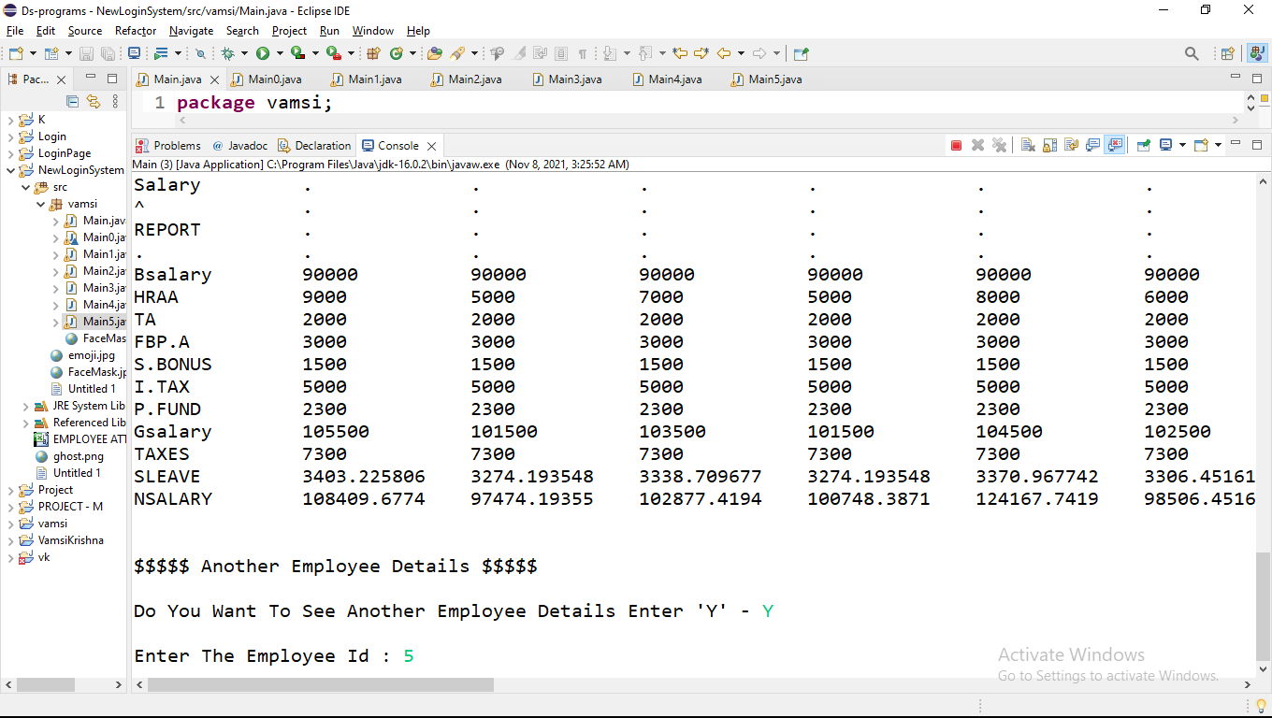

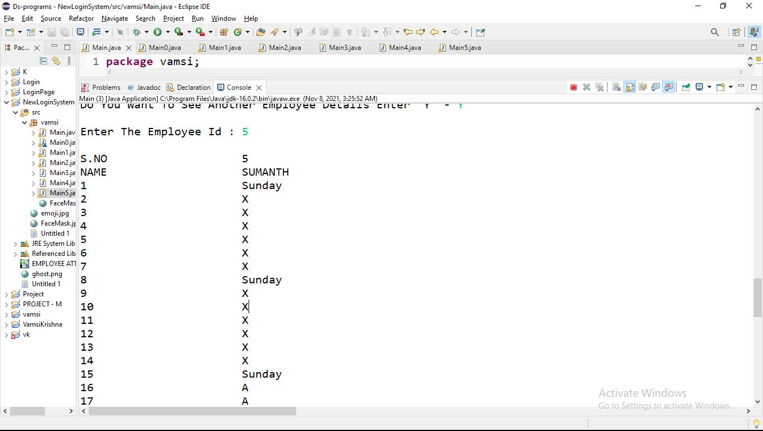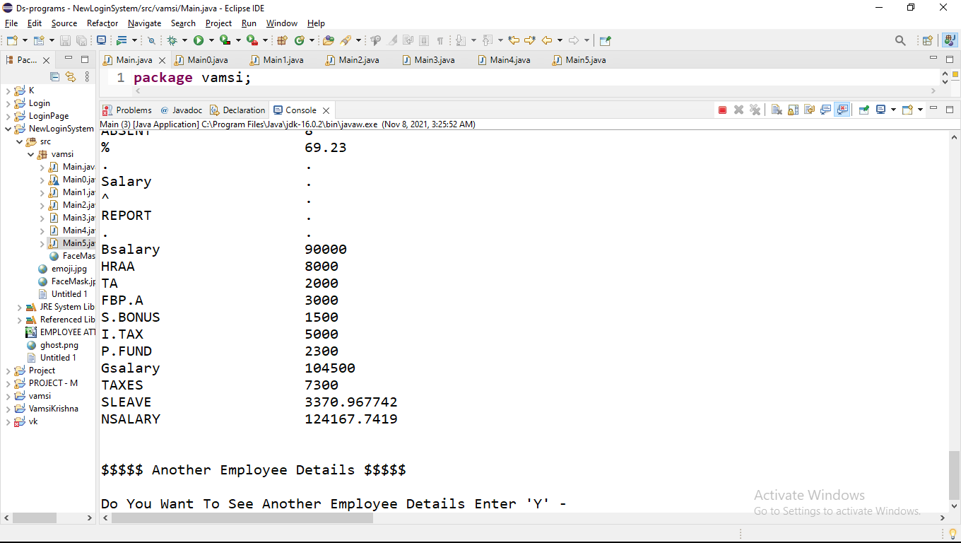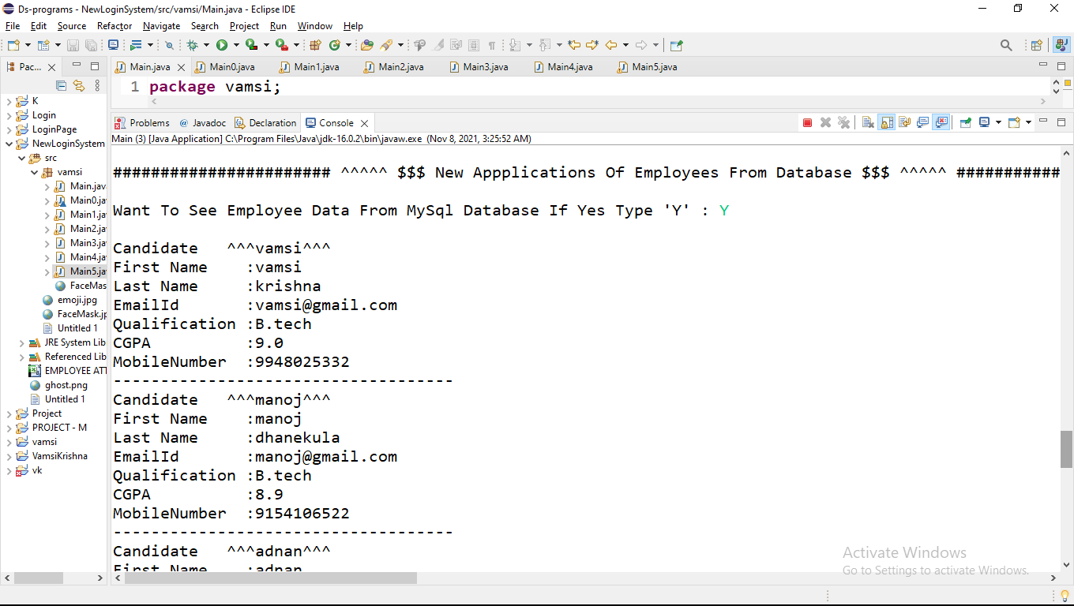

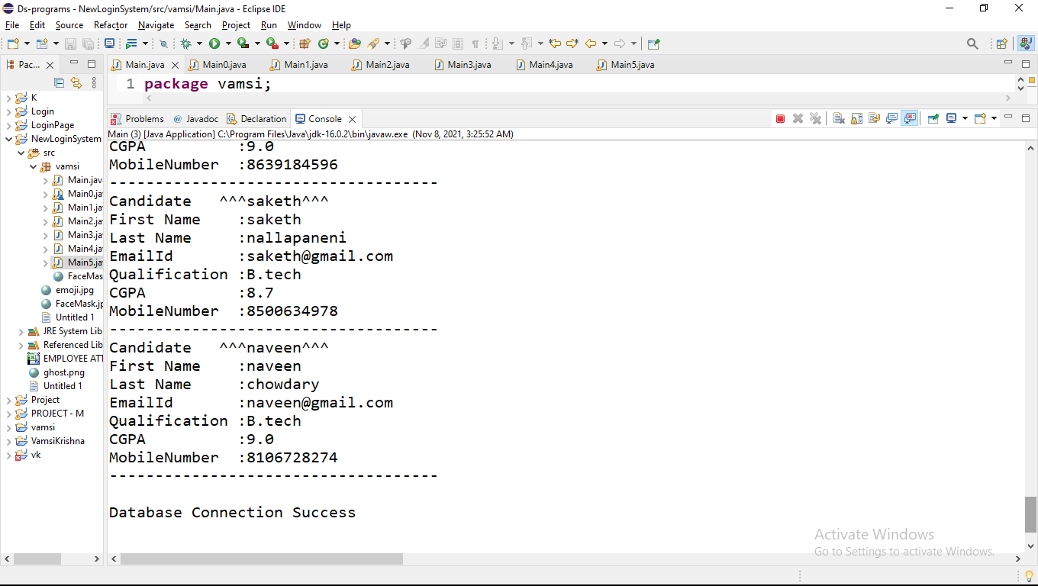

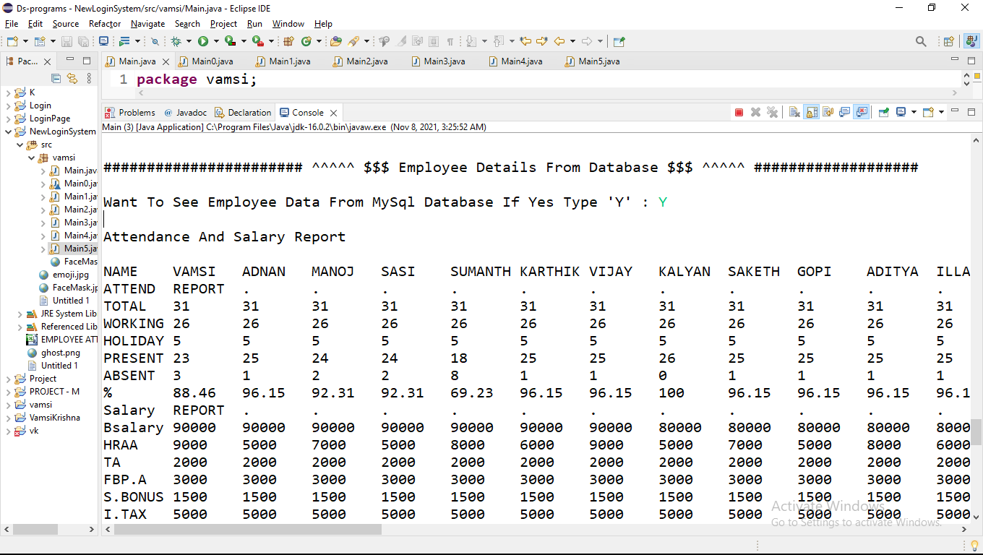

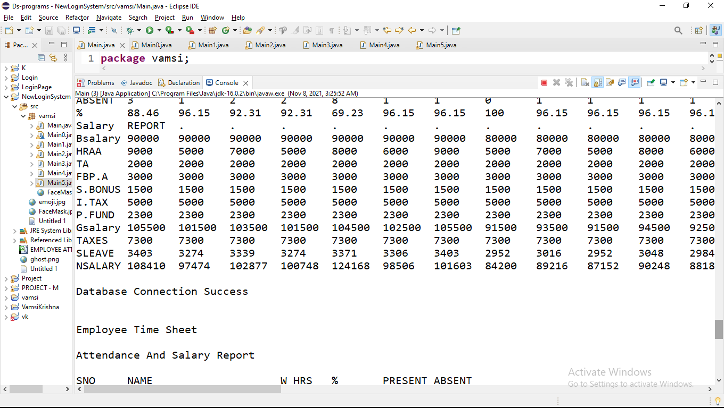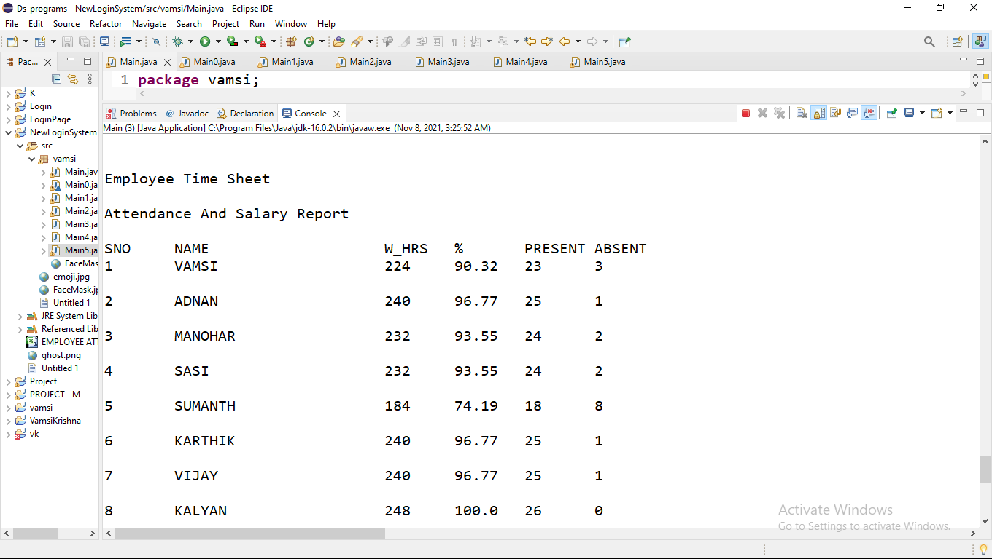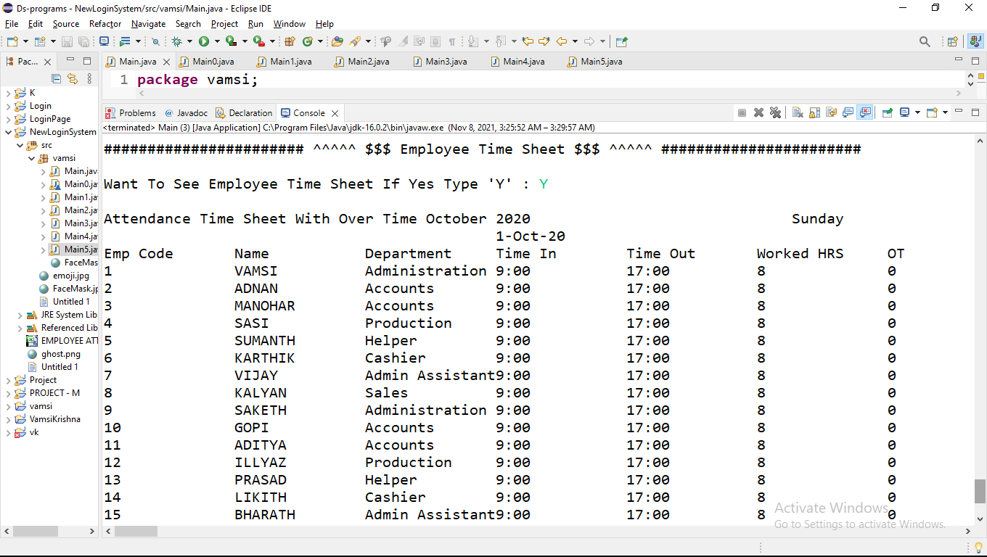

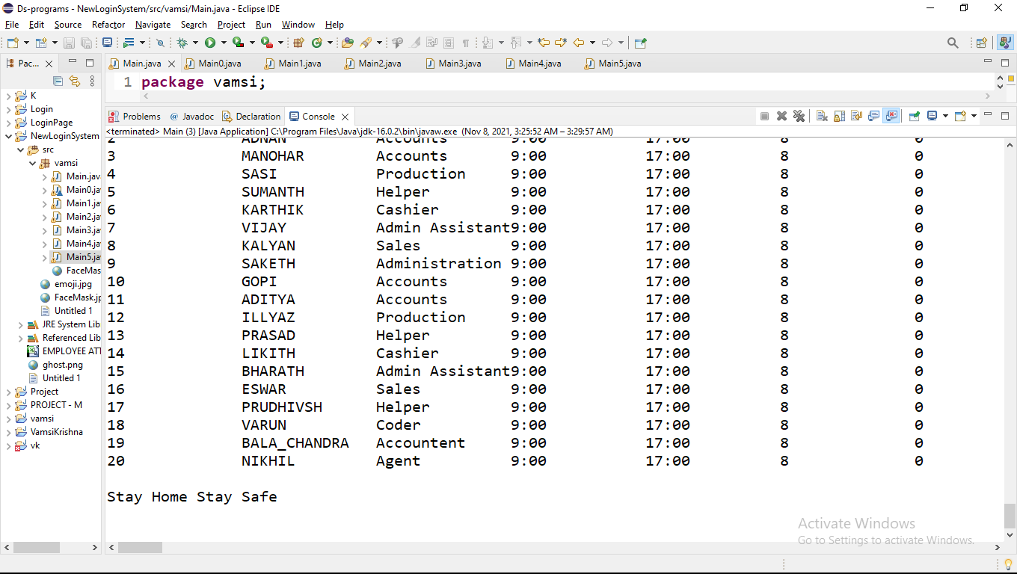

CSV FILE OUTPUTS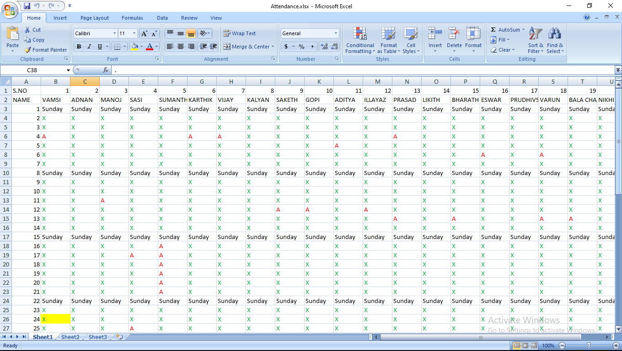

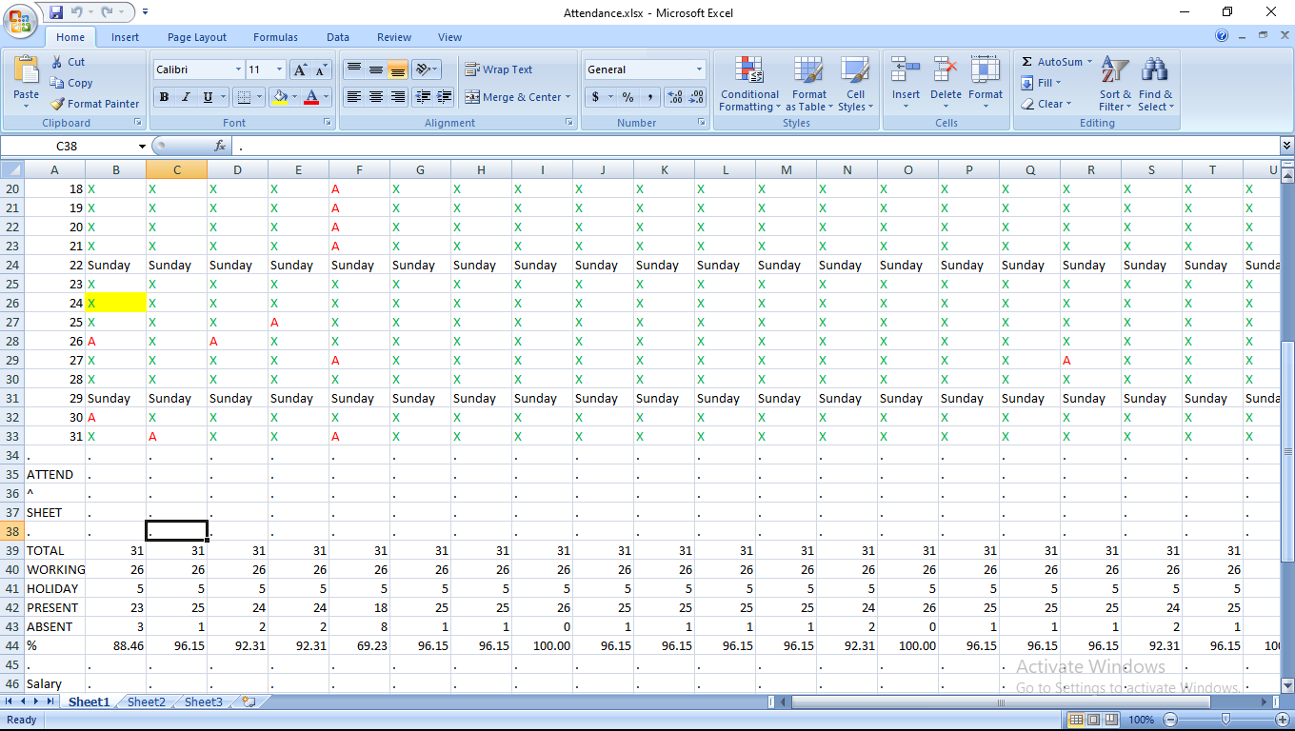

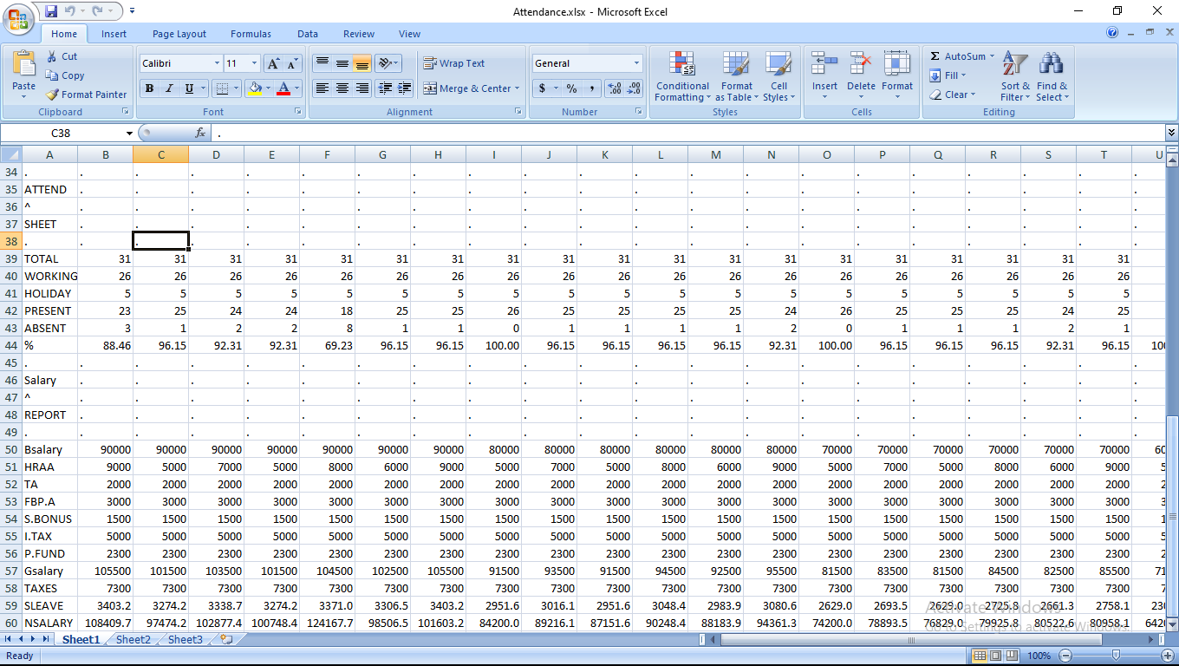

# Time Sheet Outputs

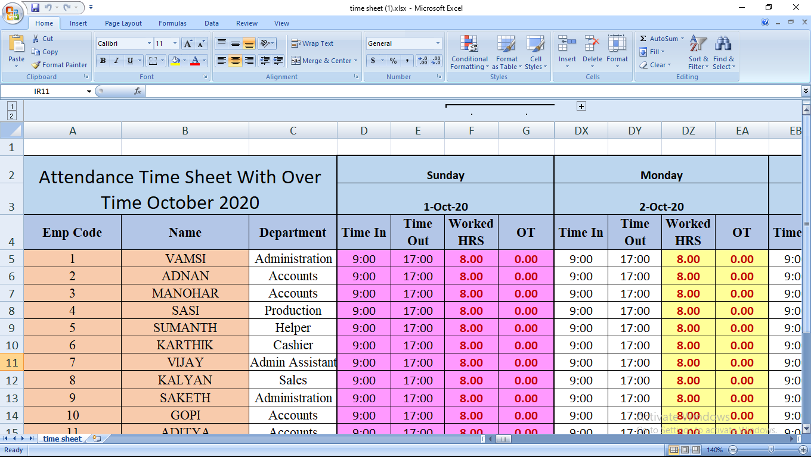

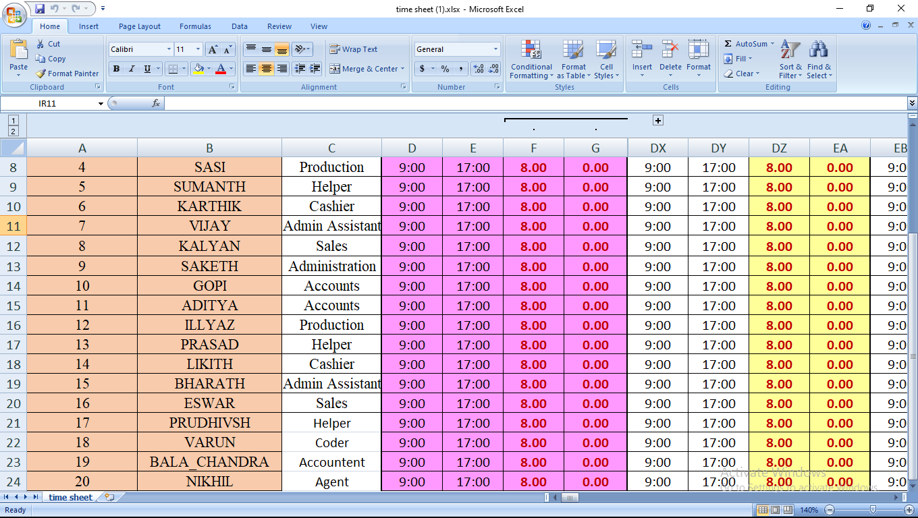

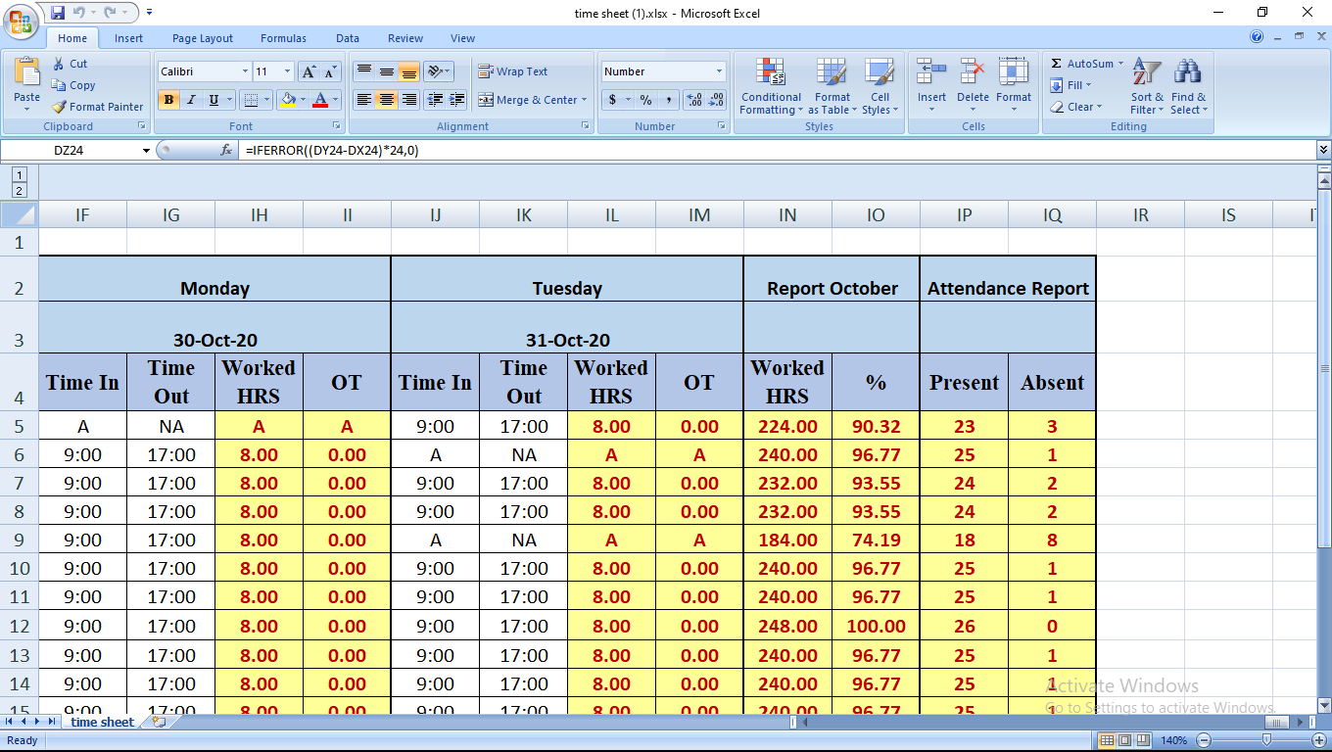

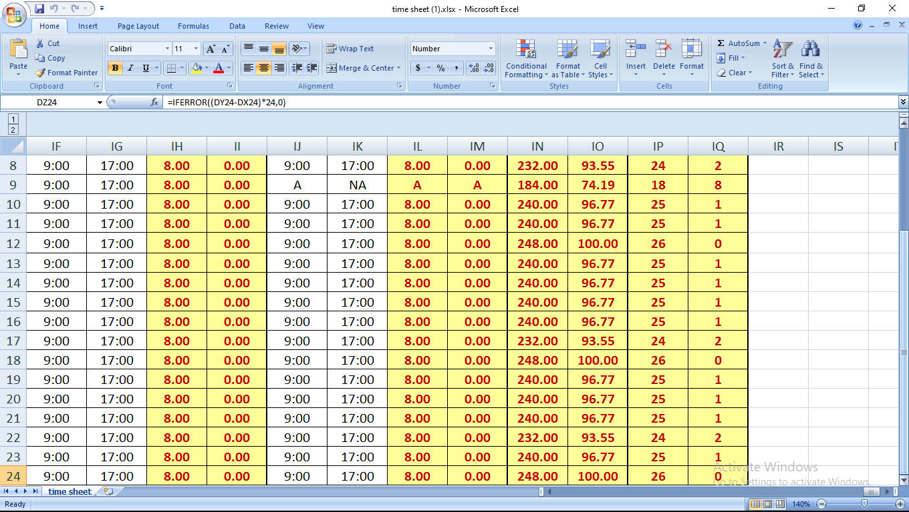

DataBase Screenshots

USERNAME AND PASSWORD IN DATABASE

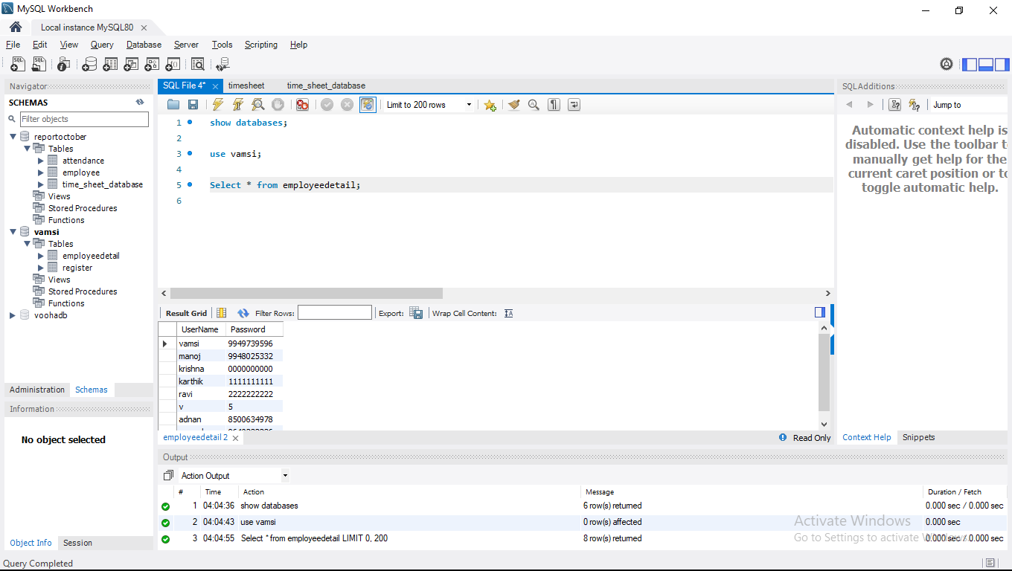

Employee Registration Details

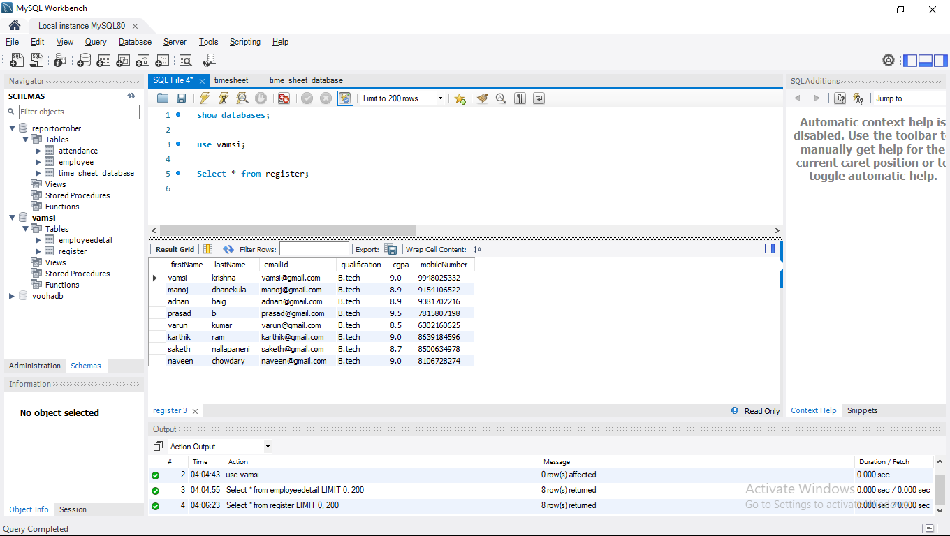

Employee Details in Database

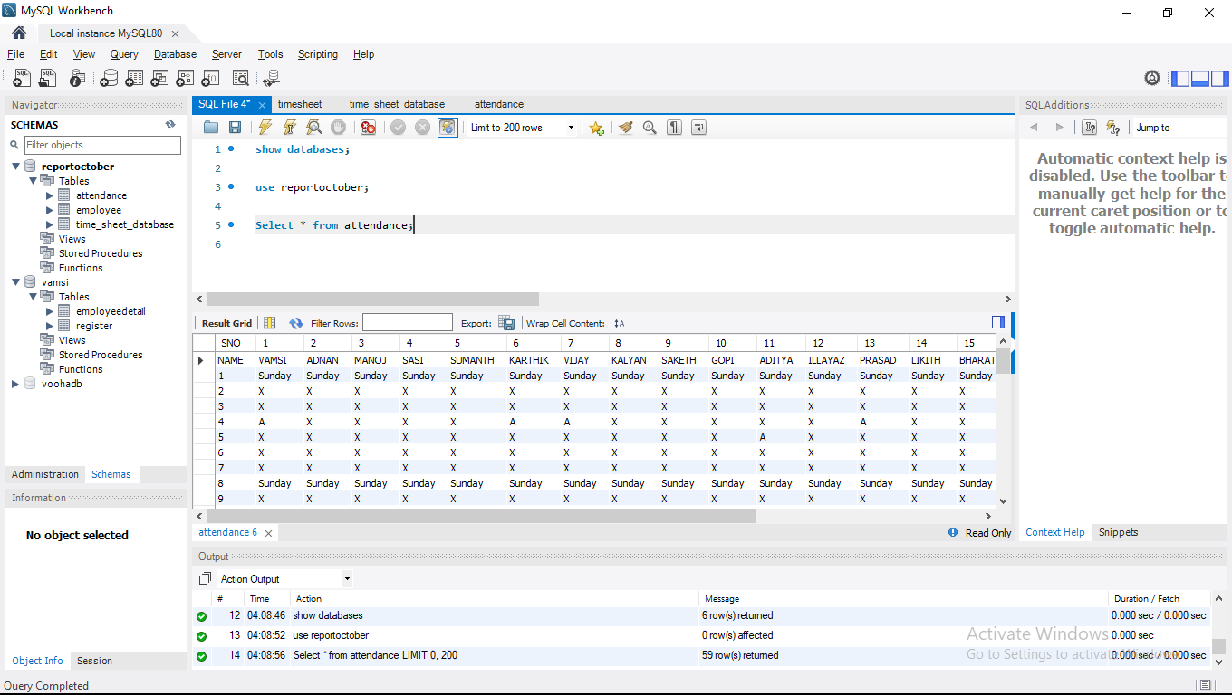

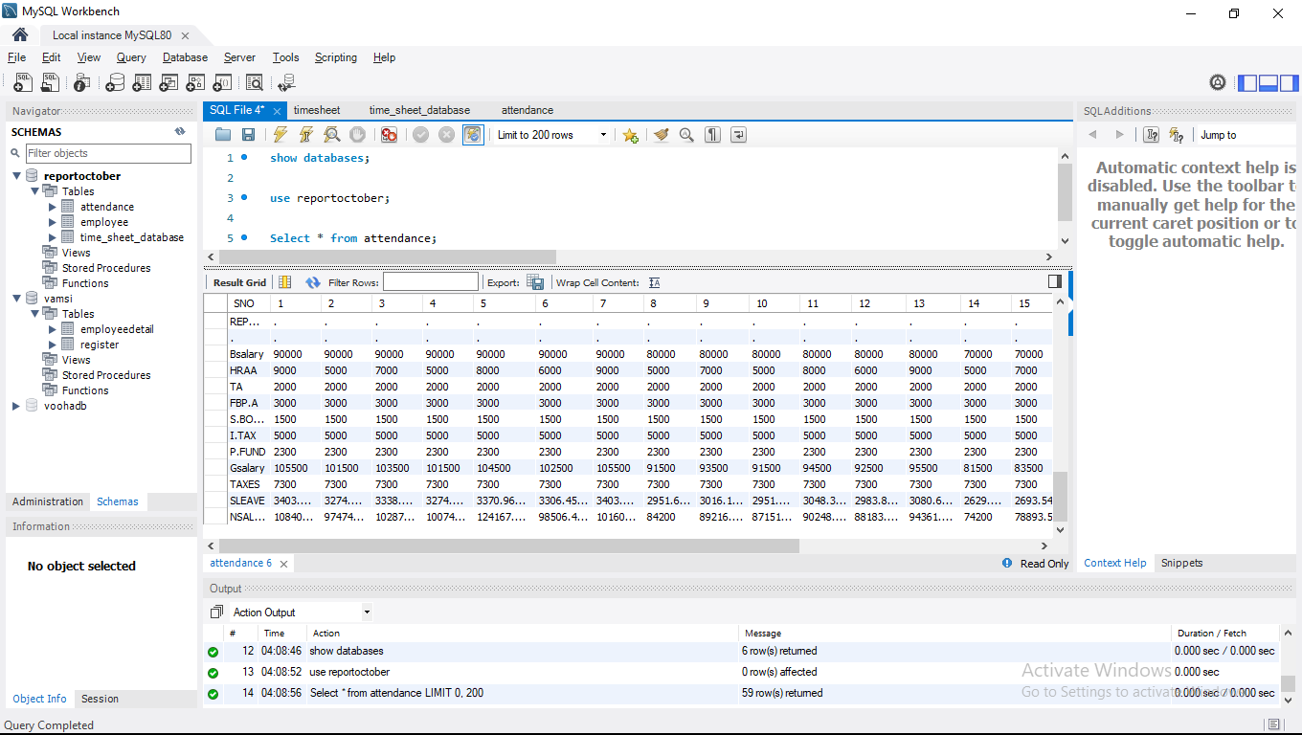

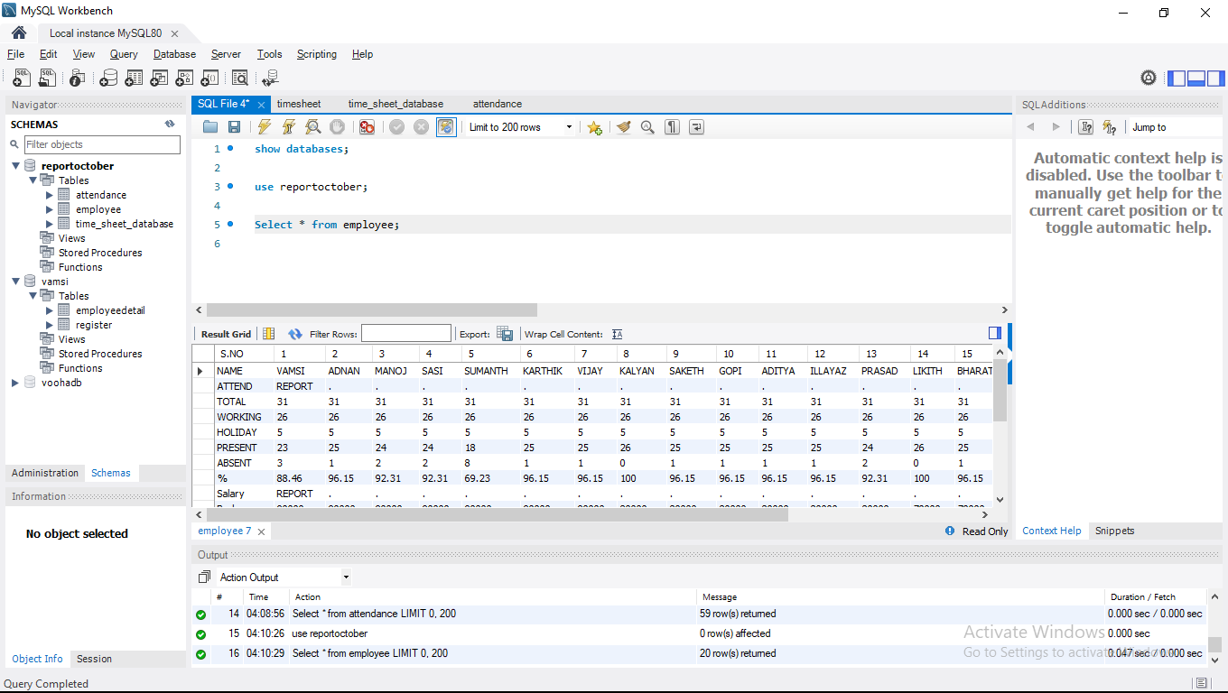

# Time_Sheet_Details From Database

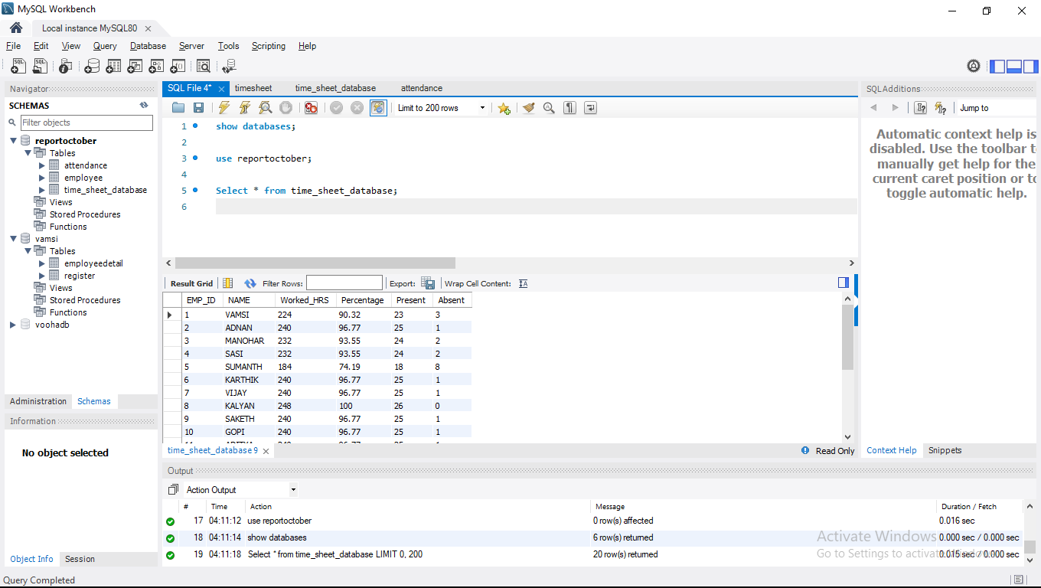

# 🙂😍 Thank you 😍🙂